WRITING CENTERS IN MULTILINGUAL SETTINGS
A WORKBOOK

americanenglish.state.gov

TABLE OF CONTENTS
Introduction iii
How to Use This Workbook iv
What Is a Writing Center? 1
Traditional Functions of a Writing Center 1
Writing Centers in the 21st Century: Multiliteracy Centers 3
The Global Writing Center’s Expanded Role: WAC, WID, Language Center, Research Center,
Career Development Center 3
Student Oriented vs. Faculty Oriented 6
Starting and Sustaining a Writing Center 9
How to Get Administrative Support From Your University 9
Defining Your Audience: Client Profiles, Client Needs 14
Sample Needs Analysis: Faculty 14
Administration 21
Example Administrative Positions 21
Director 21
Office Assistant 23
Technical Assistant 24
Tutor 25
Setting Up Your Online Presence 27
How to Set Up Gmail and Google Docs 27
How to Set Up a Website 42
How to Use and Start Google+ 50
How to Use and Start Twitter 53
How to Use and Start Vkontakte and Facebook 54
How to Put Writing Center Activities on Your University Website 59
Sample Webpage Information 60
Welcome 60
FAQs 60

Writing a Writing Center Handbook 63
Policies and Procedures 63
Training and Developing Staff 75
Training 75
Developing Staff 75
Best Practices in Developing and Sustaining Your Writing Center 77
The Consultation 77
Basic Writing Center Methodology and Principles for Working with Tutees 77
Practices for the Writing Consultation 78
Practices for Conversation Sessions 82
Criteria for Writing Assessment 84
References 87
Sharing Resources and Expertise 89
Writing Center Associations 89
Sample Forms 89
Consultation Permission Form 89
Overview of Services 91
Introduction 91
Faculty Support 92
Student Support 93
Online Presence 93
Facilities 93
Acknowledgements 95
Handouts

INTRODUCTION

As an English Language Specialist, I was tasked to assist a university in Samara with creating a writing center. A few months after opening the writing cen- ter, I presented on writing centers at a conference in Moscow. Recognizing the extraordinary value a writing center provides an academic community, my Russian colleagues from universities around the country asked for guidelines and help with creating a center for their academic environment.
I began writing this workbook to provide a guide to assist others through the process of creating, opening, and staffing a writing center. While this publication was originally written for a Russian audience, the material can be easily adapted and used worldwide.
If you are interested in starting a writing center, you have come to the right place. In this workbook, we will be reviewing everything you need to devel- op your first writing center. Detailed information about the history and theory behind writing cen- ters is not the focus of this workbook. Instead, we

will be looking briefly at important discussions that informed and changed writing center practice. Our focus is to use these discussions to stimulate your thoughts and goals towards developing your own writing center. While you might be inclined to skip the questions at the end of each section—don’t.
By answering these questions, you will be actively creating your first writing center handbook.
I wish you the best in your endeavors and hope that this workbook helps you to get off to a great start. Unfortunately, we will not be able to cover every element that you will encounter while building your writing center. Not only will this be an opportunity for you to problem solve, but this will be a great opportunity for you to reach out to others in your country or region to ask questions and get advice. Hopefully, this will lead to a won- derful partnership and to your development as a member of the global writing center community.

Happy planning!

Eve Smith
English Language Specialist, Russia, 2016

How to Use This Workbook
Each section of this manual is divided into two parts: background information and “Center Creation Questions.” In the background information section, you will find a discussion of writing center theory and practice in the United States. You will learn a con- densed version of the history of writing centers and their purpose. The following section, entitled “Center Creation Questions,” will help you analyze the back- ground information and apply it to your own context.

All of the questions are also provided as printable and modifiable handouts. The answers you provide will in turn help you identify your center’s audience, needs, purpose, and development strategy. By answering the Center Creation Questions as you go through this book, you will develop the core information for your writing center handbook. Finally, a list of articles, vid- eos, or books at the end of each section will guide you to where you might find more information.

1

WHAT IS A WRITING CENTER?

Traditional Functions of a Writing Center

Writing centers have been on college and university campuses in the United States since the 1930s (Mur- phy and Law 1995; Murphy and Sherwood 2011). Originally created to assist writers who were strug- gling to cope with academic writing, the writing center has evolved over the past century in tandem with the evolution of the idea of what it means to be a writer.
In the 1930s and 1940s, writing labs and centers were used as a means to help those who could not commu- nicate their ideas clearly and concisely through their writing. In some cases, this was due to grammar and spelling. In other cases, this was due to the student’s inability to structure an argument within a paper.
During this time, students were sent to the writing lab to sort out their academic issues.
As one can imagine, being sent to a writing lab to work on the weakness in one’s writing so that a test could be passed in order to graduate was not inspiring. In his seminal essay, “One-On-One, Iowa City Style: Fifty Years of Individualized Writing Instruction,” Lou Kelly (1980) describes the negative emotional impact the writing labs originally had on both the teachers and students who passed through their doors. The obsession with writing for tests and formulaic papers was creating the perception that
writing was a chore to labor through rather than a tool for learning. In other words, writing was thought to be only a skill to be mastered through rigorous practice
with grammar books and writing structures. However, Kelly saw that students could and should “experience writing as learning” (22). This was the beginning of a shift in the understanding of the purpose of writing in academia.
Murphy and Law (1995) and Murphy and Sherwood (2011) outline the continual shift in our un- derstanding of the place of writing in academia in their books Landmark Essays on Writing Centers and The St. Martin’s Sourcebook for Writing Tutors. Each book highlights the path of exploration and understanding researchers have taken to develop the structure of
the learning environment at a writing center. Read- ers watch the arguments shifting from writing being perceived as an individual act to being considered
a social act. Writing centers have evolved to match this change in perception. The change in perception towards social constructivism has placed a greater influence on collaboration among peers (Murphy and
Law 1995). The impact is that consultations at writing centers have become less hierarchical. The tutor was no longer perceived as an authority, but as a peer. In other words, when visiting a writing center today,
one will have a tutor who is a peer rather than a tutor who is an expert in his field. This change in structure can be culturally challenging for people coming from outside the more individualistic cultures of the United States and Europe.

Writing centers in the United States and Europe are exploring the challenges presented by cultural differences in working with international students who struggle to view the tutor as a peer rather than an authority figure. There is a wide body of research
that explores this issue. As an institution outside of the United States, the elements that need to be discussed in creating a writing center are the culturally embed- ded notions of what it means to be a writer and what it means to be a tutor.

Center Creation Questions
- What does it mean to be a writer in your academic culture? Do students in your institution write papers in English? If yes, what kinds of papers, e.g., letters, summaries, essays, etc.? Is this done alone? Is this done with input from peers or the teacher?
- Do you believe the tutor would be more effective in the role of a peer, or as an author- ity? Why?

- Questions to ponder: If you do not have any- one in a science department with an English level high enough to be a subject authority on a science topic, how will you train tutors to work with researchers from different scien- tific backgrounds? How will you train tutors to work with the different genres of papers (business, science, humanities)?

See Handout 1: Writing Center Creation Questions for worksheet.

Your answers to the above questions will help you to define the role of the writing center and its tutors. For a more extensive look at the body of literature sur- rounding writing center development, read:
Kelly, L. 1980. One-on-one, Iowa City style: Fifty years of individualized writing instruction. In Landmark essays on writing centers. eds. C.
Murphy and J. Law, 11–25. Davis: Hermago- ras Press.
Murphy, C., and Law, J. eds. 1995. Landmark essays on writing centers. Davis: Hermagoras Press.
Murphy, C., and Sherwood, S. eds. 2011. The St.
Martin’s sourcebook for writing tutors. 4th ed. Boston: Bedford/St. Martin’s Press.

Writing Centers in the 21st Century: Multiliteracy Centers

The writing needs of the 21st century are much more than the esoteric papers and essays required of students in the 1990s. Simply looking at the shift in marketing and social media needs over the past decade shows the different types of discourses in which academic institutions will need to teach
students how to work (Tapscott 2012; Hlavac 2014). Writing now includes new methods of idea expression and e-literacy. In other words, being a writer now includes being able to integrate video or sound into a
document. In addition to simply integrating the video or sound, writers will need to write the script of the video or sound. This means that tutors will need to be “producers who create sophisticated tools to support students working on both digital and non-digital projects” (Murphy and Hawkes 2011, 362). Tutors will need to be fluent in the writing of the 21st century, which includes working with images, video, sound, and other technologies.

The Global Writing Center’s Expanded Role: WAC, WID, Language Center, Research Center, Career Development Center

Writing Across the Curriculum (WAC)
The theoretical underpinnings of this program began in the 1980s with the belief that writing is learning (Kelly 1980). In WAC programs, undergrad- uate students should have writing as a part of all their coursework. For example, if a student is in a bioen- gineering course, that student would be required to write papers about bioengineering using the structure of that specific discipline. In this case, the student would most likely write lab reports, journal articles, etc. The argument is that students learn best about their discipline by writing for their discipline.
Universities and institutions that have WAC pro- grams often use the approach called “Writing in the Disciplines” (WID) as a means of implementing WAC.

The WID approach believes that each discipline has a specific language and forms of expression. Because of this, it is best for students to be trained in writing within their discipline.
One of the opportunities that the WID approach allows is for the professor to have a class tutor. The tu- tor is typically a graduate student in the field. Having a class tutor is ideal in that the tutor will know exactly what has been covered in the class, what the profes- sor expects from the students’ writing, and what the assignments are that the students are supposed to be working on. Students can visit the tutor at the writing center to discuss their assignments.

Career Development Center
Many institutions in the United States have shifted to career development centers. These centers offer a wide variety of programs including individual tuto- rials, group classes, and tutorials on a wide variety of topics. Some of these topics include CV and resume writing, personal statements, giving presentations, conducting research, language issues, etc. Career development centers might also help students locate internship programs or study abroad opportunities.

For more information on multiliteracy writing centers, read:
Hlavac, R. 2014. Social IMC: Social strategies with bottom-line ROI. Amazon: CreateSpace Independent Publishing Platform.

Kelly, L. 1980. One-on-one, Iowa City style: Fifty years of individualized writing instruction. In Landmark essays on writing centers. eds.
C. Murphy and J. Law, 11–25. Davis: Hermagoras Press.
Murphy, C., and Hawkes, L. 2011. The future of mul- tiliteracy centers in the e-world: An explora- tion of cultural narratives and cultural trans- formation. In The St. Martin’s sourcebook for writing tutors. 4th ed. eds. C. Murphy and
S. Sherwood, 361–374. Boston: Bedford/St. Martin’s Press.
Tapscott, D. 2012. Four principles for the open world. Talk presented at TEDGlobal. June 2012. https://www.ted.com/talks/don_tapscott_ four_principles_for_the_open_world_ 1?language=en (accessed February 23, 2016).

Center Creation Questions: Defining a Purpose for Your Writing Center

  - Which type of center seems most suitable to use in or for your environment?
  - Poll the faculty in your institution and ask the professors what types of assignments they give. Do they have students create a podcast, a video, and other forms of media as part of an assignment?
  - Do any of the professors you work with have to create videos or other forms of media for professional conferences or their classes?
  - Which e-literacy skills will your center include?
  - What training will your tutors need to master e-literacy skills?
  - How will you ensure that your tutors contin- ue to train in evolving e-literacy skills?

Student Needs
- Is there a need for students to write papers or abstracts for subjects other than English?
- Is having writing tutors for specific classes a possibility at my institution? Why or why not?

- Could graduate students get extra credit or a reduction in expenses by being a course-spe- cific tutor if they have a good level of English?

Questions for a Language Center
  - Will your center offer language classes? If yes, with what focus? To whom? How often?
  - Will your center offer workshops on common academic writing mistakes in English? If yes, to whom? How often? How will you choose the topics for the workshops?

  - Will your center offer handouts or online re- sources that cover common academic writing mistakes in English? If yes, who is going to create / review / pilot / post them?
  - Will your center offer speaking activities like discussion clubs? Listening activities? If yes, with what focus? To whom? How often?

Questions for a Research Center
    - Will your center train students in research methods? Why or why not?
    - Will your center have printers and computers with access to online journals? If yes, will the center allow students and researchers to print

online articles?
    - Will your center have a relationship with the institution’s library and arrange library tours or workshops on using library resources?

See Handout 2: Defining a Purpose for Your Writing Center for this worksheet.

Student Oriented vs. Faculty Oriented
Who do you believe will be your primary clientele?

In some cases, student tutors are not directly paid.

In the United States, writing centers are generally student-oriented. Students from any of the institu- tion’s programs are welcome to use the services of the center. In most cases, the center is free for the students to use as much as they would like during the semester. The institution may pay for the center’s budget out of its general administration fees, or they might charge the student a fee as part of student services. Other student services might include a health center, pool, gymnasium, student council, club activities, etc.
Undergraduate and graduate students from a wide variety of disciplines staff the centers, with a faculty member acting as the manager. Each tutor goes through an interview process, which includes a writing sample, writing assessment, and face-to-face interview component. After this process, the tutors will frequently undergo extensive training in how to talk to their peers and discuss the writing presented to them. In some cases, students might take a semes- ter-long course that teaches them about writing and how to give feedback for course credit. At the end
of the course, or during the course as part of their coursework, students may be required to be tutors in the writing center. This allows the center to ensure that there will always be tutors available. As the center grows, center administration may find it difficult to keep up with the consultation demand without a simi- lar program in place.
They may be given discounted or free tuition. In other cases, working in the writing center is counted as an internship. Alternatively, students might be hired as part-time employees of the writing center.
Faculty-oriented centers have different needs. Since the primary clientele will be researchers and professors from the institution, it is unlikely they would feel comfortable having a consultation with a graduate student regardless of the student’s language ability. In this case, the brunt of the consultations will fall on the English Department or other foreign language department with staff who have the ability to consult on a research article for an international publication. This will mean that the teachers must be well trained in academic writing for research and
publication. This will also mean that the teachers will be asked (or required) to work extra hours outside of their regularly scheduled classes for free.
It is important that the faculty understand what a writing center consultation means. Sometimes faculty mistakenly believe that a writing center is a proof- reading or translation service. Be sure to note in your advertisements and on your website that the faculty will be working with a peer who will help them to more clearly express their arguments through a series of questions. The center will want to make sure that the tutors do not rewrite or translate documents for faculty, and that all faculty are aware of international copyright laws.

Center Creation Questions: Writing Center Orientation
      - Will you offer a student- or faculty-oriented writing center? Why?

Student-Oriented Center Creation Questions

- What languages will your writing center sup- port? Do you have English as the medium of instruction? If so, how will the writing center support students’ development in academic writing in English?
- Will your center offer writing center consulta- tions for students?
- Will your center offer writing workshops for students?
- Who will provide the consultations for the students? Other students or professors?
- How will you train your tutors to work with students?
- Who will pay for the consultation services?
- How will you advertise your services to students?

Faculty-Oriented Center Creation Questions
- How many faculty do you believe will use the writing center service?
- Are there any faculty from different depart- ments with a high level of English who would be willing to consult?
- How will you ensure that all faculty doing consultations are able to give appropriate feedback?

- How will you train your tutors to work with faculty?
- How will you advertise your services to faculty?
- How will you ensure faculty understand the purpose of the writing center is to give feed- back? How will you make sure they do not expect a proofreading service?

See Handout 3: Writing Center Orientation for this worksheet.

9

STARTING AND SUSTAINING A WRITING CENTER

How to Get Administrative Support From Your University

Universities have a great challenge to communicate in- ternationally. Establishing an English language writing center is an effective and efficient strategy to help your institution understand the criteria for global academ- ic communication. The purpose of a writing center
is to serve the immediate needs of academics with consultations on writing for international publication and to provide workshops on academic writing skills for students, faculty, and research staff. Additionally, writing centers may be used to train faculty in best practices for teaching writing courses, integrating writing assignments into courses in different subject areas, giving feedback on student writing, and learning to teach the conventions of writing in English within
a specific discipline (i.e., Writing Across the Curricu- lum [WAC] and Writing in the Disciplines [WID]).
The academic landscape is changing as universi- ties compete with each other for the highest ranking in order to become known as a “quality” institution. One of the measurements of “quality” is the number of English academic papers published in international journals. A well-organized and managed writing cen- ter is a key component of an administrative strategy
to establish oneself as an outstanding institution. In addition, this system of new academic communication methods for an institution’s language policy gives an
opportunity to create a communicative ideology to support the internationalization process in education.
Administrative support is essential to establish a writing center within the university structure. In order to secure this vital support as a part of the educational environment of educational and research institutions, several steps of development need to be formally addressed with institution officials.
Step One: Create a Strong Institutional Desire to Start a Writing Center
For this step, the following questions need to be answered:
  - If the writing center receives funding, how does this funding represent the institution’s perception of writing centers in general?
  - What are the specific issues regarding writing skill development that need to be addressed (e.g., remediation of student writing skills, improvement or development of academic writing for publication within a specific department, etc.)?
  - What are the goals of the writing center? What are the institution’s language policy goals? Where do the writing center’s goals and the institution’s goals intersect?
(Cirillo-McCarthy 2014)

Answering the questions in Step One helps define the role of the writing center within the institution and how this role supports and enhances the institu- tion’s language policy. Through brainstorming
with key center developers and eliciting survey responses to Question 1 and Question 2, the writing center administrative leadership can develop an evi- dence-based “story” to influence a variety of potential funding sources and networks of support for the start- up of the center (Cirillo-McCarthy 2014). Answers to Question 3 are valuable for identifying specific ways the writing center can support other departments’ programs to help the institution achieve its strategic goals. For example, if one of the institution’s goals is to increase publication of papers and abstracts in a spe- cific department, the writing center can approach the department’s administrative leadership and academic staff to outline how the center can help the department achieve its goal (Cirillo-McCarthy 2014). The same idea applies to the university leadership. The short- term and long-term plans of the writing center can be presented to the institution’s administration to garner support. This is especially helpful when special care has to be used to convince university leadership that they should fund the writing center.
Step Two: Complete a Needs Analysis
A needs analysis is a formal process of describing problems and identifying possible solutions. It helps to define writing center policy and create a business plan. A needs analysis helps to identify the com- ponents of the writing center by outlining what the expected audience needs. Completing a needs analysis is a crucial step that should be done as part of the planning process.
The following pre-planning questions need to be answered as part of the needs analysis:
- What is the writing center going to be called?
- Where is the writing center going to be? How big will it be?
- How many tutors will you have? How many hours will each tutor work?
- How many administrators will you have? How many hours will administrators work?
- What will be the writing center’s hours of operation?
- What resources will you have access to?
- What types of services will you offer (in the short term, mid-term, and long term)?
- What won’t the writing center do?
(Lee 2015)

Below is a sample needs analysis created by the Samara Academic Consultancy Center.

Needs Analysis Questionnaire
Dear colleagues,
We would be grateful if you could answer the following questions. This will help us to offer English courses that meet your needs and level of proficiency. Thank you.

- Name, surname:
- Circle a category: researcher, teacher, administrator
- Department you work for:
- Identify your needs. Please put a check (ü) in the two columns, where appropriate.

I CAN understand | A. Listening | I WOULD LIKE to  understand
 | 1) general English in such situations as in the street, at the airport, socializing with colleagues, etc.
 | 2) lectures and presentations in my field of study
 | 3) official discussions and negotiations
 | 4) listening texts from electronic resources: audio and video recordings, webinars, Skype conferencing, etc.
 | 5) other (write down)

I CAN read | B. Reading | I WOULD LIKE to  read
 | 1) business emails
 | 2) personal correspondence
 | 3) research articles and books in my field of study
 | 4) magazines and newspapers
 | 5) novels and stories
 | 6) internet resources: blogs, forum posts, etc.
 | 7) instructions, official orders
 | 8) reports
 | 9) manuals
 | 10) curricula and syllabi
 | 11) abstracts
 | 12) reviews
 | 13) official announcements
 | 14) other (write down)

I CAN | C. Speaking | I WOULD LIKE to
 | 1) socialize, discuss everyday situations
 | 2) discuss professional topics
 | 3) give lectures in English
 | 4) make conference presentations in my field of study
 | 5) take part in formal discussions and negotiations
 | 6) talk on the phone, Skype
 | 7) other (write down)

I CAN write | D. Writing | I WOULD LIKE to  write
 | 1) formal letters
 | 2) emails
 | 3) CV / resume
 | 4) reports
 | 5) abstracts
 | 6) summaries
 | 7) reviews
 | 8) research articles
 | 9) media posts: blogs, forum posts, etc.
 | 10) instructions, orders
 | 11) research reports
 | 12) manuals
 | 13) syllabi
 | 14) announcements
 | 15) calls for papers / conference programs
 | 16) texts for a public presentation / lecture
 | 17) grant proposals
 | 18) other (write down)

- Circle how many hours per week you would like to spend studying English.

1 3 5 more

Thank you. We look forward to seeing you at our English workshops.

See Handout 4: Needs Analysis Questionnaire for this document in an editable format.

Step Three: Create a Strategic Plan
A business plan includes the goals of the writing center and a plan of action to reach those goals over a specific period of time. The elements of a business plan are: program goals; communication strategies;
action plan strategies; and required administrative and financial (i.e., budget) support to achieve program goals. The most effective plans are written by key staff who are engaged in developing writing center work and who are familiar with potential administrative concerns or problems within the department and the institution. Defining problems and giving potential solutions as part of the business plan’s action strat- egies may effectively answer administrative officials’ concerns and result in approval and support.
Clearly defining specific action steps or policies related to financial issues is a very important step toward getting the administrative support needed to fund the start-up of a center and to sustain the center once it is established. The business plan should include financial information and an action plan needed to achieve the overall goals of the writing center. Issues to be addressed include the following: how many positions are going to be in the center; how tutors will be paid; how the Center Director will be paid; and how any administrative support staff will
be paid. For example, tutors may be paid for each hour of consultation and workshop presentation and for the preparation time required to perform these duties. The Center Director may have a fixed monthly salary for administrative work that includes managing
communications, administrative duties (e.g., commit- tees, long-term planning, human resources manage- ment, collaborations, etc.), and financial duties. An Office Assistant may be paid a monthly stipend with set hours to handle administrative duties (e.g., forms, calendars, appointments, reports, copies, budget requests, etc.). Support duties that can be divided be- tween tutors and student assistants need to be defined, including the time required to complete the responsi- bilities. Other financial issues to be included are soft- ware and computer requirements; publicity costs (e.g., flyers, videos, etc.); office and copy supplies; materials and equipment; orientation and ongoing training; and professional development costs.
Step Four: Develop a Staff Training Plan
At the start-up of a writing center, tutors may have various levels of language and writing proficiency. This information should be determined as part of a tutor-specific needs analysis and should be used to budget for training needs as part of the business plan. For example, the teachers who volunteered to be tutors at the Samara Academic Consultancy Center wanted workshops on writing abstracts. A series of workshops were created to help them master the structure of an abstract and reading the guidelines of a journal to ensure the tutee was writing in the correct style for the academic journal.
Start-up and subsequent budgets should include expenses related to orientation for new staff and any individualized training that is needed.

Additional training and professional development needs that should be included in budget preparation are departmental, local, regional, national, and/or in- ternational workshops (e.g., registration, presentation, travel expenses) and ongoing staff training during the semesters.
The following sections include needs-analysis process information, forms and instructions, and examples of administrative position descriptions.
Cirillo-McCarthy, E. 2014. Kairos & stasis in writing center administration. Academic Exchange Quarterly 18 (4): 1–6. http://rapidintellect. com/AEQweb/5530z4.pdf (accessed March 20, 2016).
Lee, A. 2015. Writing center administration. Presen- tation for United States Speakers Program on Writing Center Development at the National University of Kyiv-Mohyla Academy, Kyiv, Ukraine.

Defining Your Audience: Client Profiles, Client Needs

As you have worked through this workbook, you have been actively defining your client profiles and needs. In this section, you will work on putting all the
pieces together. One of the best ways to begin defining your programming is by looking at the needs of your expected audience. A simple needs analysis can serve two purposes. First, it will define how your target au- dience uses writing. This will allow you to choose the best programming to support your audience. Second, a needs analysis can be used as a tool for academic
community engagement. When you involve the com- munity in the creation of the writing center, they are more likely to use it. Firstly, this strategy helps inform the community about the creation of the writing center and what its intended purpose will be. Secondly, as the community gives feedback, they feel that they are
a part of the creation process and may be more likely to pay attention to the opening of the writing center so that they can pay it a visit.

Sample Needs Analysis: Faculty
The following is a sample letter explaining the pur- pose of your needs analysis to the faculty that will be participating in your survey. Again, feel free to change

or alter the forms to suit the needs of your specific institution. The actual needs analysis created follows this statement of purpose.

Please read the following information carefully.

Survey takers: The survey will be used to gather information about the writing needs, both perceived and actual, of the Kyiv-Mohyla academic community. The English Writing Center (EWC) at the English
Department will use the information gathered to define the goals and scope of the EWC. This writing center will serve the needs of the academic community by providing:

Students | Faculty (All academic staff)
- one-on-one tutorials  - workshops in academic writing (including ESP)  - workshops in avoiding plagiarism  - workshops in creative writing  - workshops in application essentials  - workshops in business essentials  - workshops in research writing essentials  - other resources as determined by the survey | - referrals for students to work on faculty-specified issues in their writing  - exercises on writing and grammar  - resources on writing structure and grammar  - workshops on topics that include: plagiarism, summary writing, integration of quotations, and learning strategies  - workshops tailored to instructors’ needs

Signing this form implies that you have read and understood the purpose of this survey and how the results will be used, and it expresses your agreement to allow your answers to be analyzed and included for research purposes. We need you to sign your name
to prove that you actually took the survey so that it is valid for data collection for research purposes. Once you have signed the form, you will be given a survey with a number, and your name will not appear on any data analysis or reports.

Surveyors:
- Make certain that the survey respondents have read the information sheet about the survey.
- Answer any questions they might have about the survey itself or its outcome.

- When giving a survey, remember to write the number of survey respondents next to their names on the registration form. It is crucial that you have correctly entered in this information so that the results may be processed.

Printed Name | Signature | Email and/or Mobile | Can we contact you with further ques- tions? Circle Yes or No | Survey Number
Eve Smith | Eve Smith | important@yahoo.com | Yes No | 1
 |  |  |  | 2

The following example is of a needs analysis that was developed at the National University of
Kyiv-Mohyla Academy by the members of the Writ- ing Center Development Committee. While your institution may have a different audience for the writing center than Kyiv-Mohyla, you may find that adapting some of the questions will meet your needs.
Take into consideration how you will collect this information. Will you have a printed form that the faculty can fill out? If yes, you will have to com-
pile the results yourself. I recommend using either SurveyMonkey or Google Forms and sending the survey out by email. The responses will be automat- ically recorded, and you will just need to analyze the results and decide how to use the information. In other words, email saves an extra step. However, your faculty may not be used to email. Some may not even have an email account. In that case, you may wish to ensure that all faculty are participating by sending out a paper survey.

Faculty Writing Center Questionnaire
Personal Information

Your native language: Years of teaching experience:

The name of the academic area in which you mainly teach:

Level of students you generally teach:

General Questions on Writing in English in Your Program
We invite you to give feedback in Question 9 if you feel that there was any writing item missing from the survey.

- Do your students have to write assignments or papers in English (circle): yes no

1A. If yes, estimate how many papers your students wrote in English the previous term.
1B. Students have the choice to write in their first language or in English. (circle)
yes no

- Last semester, how many written assignments (letters, essays, papers) on average in English did students submit for grading during a Bachelor study program in your field?

None | 1–3 | 4–6 | 7–9 | 10 or more | Not Applicable
[ ] | [ ] | [ ] | [ ] | [ ] | [ ]

- Last semester, how many written assignments (letters, essays, papers) on average in English did students submit for grading during a Master’s study program in your field?

None | 1–3 | 4–6 | 7–9 | 10 or more | Not Applicable
[ ] | [ ] | [ ] | [ ] | [ ] | [ ]

- On average, how many hours a week do you think your students should dedicate to writing to succeed in your course?

None | 1–3 | 4–6 | 7–9 | 10 or more
[ ] | [ ] | [ ] | [ ] | [ ]

- Which of the following do your students write in your course?

 | 1  Never | 2  Occasionally | 3  Sometimes | 4  Often | 5  Very Often
Notes during lectures | [ ] | [ ] | [ ] | [ ] | [ ]
Seminar papers (on theoretical or empirical topics) | [ ] | [ ] | [ ] | [ ] | [ ]
Research papers | [ ] | [ ] | [ ] | [ ] | [ ]
Personal reflection papers | [ ] | [ ] | [ ] | [ ] | [ ]
Technical reports | [ ] | [ ] | [ ] | [ ] | [ ]
Summaries | [ ] | [ ] | [ ] | [ ] | [ ]
Paragraphs | [ ] | [ ] | [ ] | [ ] | [ ]
Internship reports | [ ] | [ ] | [ ] | [ ] | [ ]
Proposals | [ ] | [ ] | [ ] | [ ] | [ ]
Essays | [ ] | [ ] | [ ] | [ ] | [ ]
Narrative or expressive texts | [ ] | [ ] | [ ] | [ ] | [ ]
Abstracts | [ ] | [ ] | [ ] | [ ] | [ ]
Formal letters | [ ] | [ ] | [ ] | [ ] | [ ]
Others (please list) | [ ] | [ ] | [ ] | [ ] | [ ]
 | [ ] | [ ] | [ ] | [ ] | [ ]
 | [ ] | [ ] | [ ] | [ ] | [ ]
 | [ ] | [ ] | [ ] | [ ] | [ ]
 | [ ] | [ ] | [ ] | [ ] | [ ]

Importance of the Competencies in Academic Writing
- What is most important to you when your students write a paper for a grade?
Rate the following from 1–9, with 1 being most important and 9 being least important. Finding the relevant literature about a topic
Planning the writing process
Understanding and reflecting on research methods Structuring a paper
Summarizing research sources Writing process itself
Using the right terminology for English for Specific Purposes Revising a text to make it grammatically correct
Revising a text for the right word choice

- How competent are your students in the following?

 | 1  not competent | 2  fairly competent | 3  average competence | 4  competent | 5  highly competent
Supporting one’s own point of view | [ ] | [ ] | [ ] | [ ] | [ ]
Interpreting research findings | [ ] | [ ] | [ ] | [ ] | [ ]
Integrating research findings | [ ] | [ ] | [ ] | [ ] | [ ]
Referring to sources | [ ] | [ ] | [ ] | [ ] | [ ]
Dealing critically with a subject | [ ] | [ ] | [ ] | [ ] | [ ]
Expressing one’s views precisely | [ ] | [ ] | [ ] | [ ] | [ ]
Inserting and integrating tables, graphs, and charts in a text | [ ] | [ ] | [ ] | [ ] | [ ]
Writing bibliography cards | [ ] | [ ] | [ ] | [ ] | [ ]
Writing a reference list | [ ] | [ ] | [ ] | [ ] | [ ]
Avoiding plagiarism | [ ] | [ ] | [ ] | [ ] | [ ]
Discussing previous research in the field | [ ] | [ ] | [ ] | [ ] | [ ]
Writing a stylistically appropriate paper | [ ] | [ ] | [ ] | [ ] | [ ]
Using an effective writing process (outlining, first draft, etc.) | [ ] | [ ] | [ ] | [ ] | [ ]

 | 1  not competent | 2  fairly competent | 3  average competence | 4  competent | 5  highly competent
Keeping to a writing schedule | [ ] | [ ] | [ ] | [ ] | [ ]
Considering the audience | [ ] | [ ] | [ ] | [ ] | [ ]
Accurate word choice | [ ] | [ ] | [ ] | [ ] | [ ]
Developing flow in the paper | [ ] | [ ] | [ ] | [ ] | [ ]
Editing the paper for mechanics, punctuation, etc. | [ ] | [ ] | [ ] | [ ] | [ ]
- If workshops were offered for free to help students develop study competencies, rank the order of importance for each competency (1=most important, 9=least important).
  - Discussing in class
  - Organizing group-work efficiently
  - Giving an oral presentation
  - Academic writing
  - Peer editing
  - Using technology-aided tasks (PowerPoint, Word, PDF, etc.)
  - Reading and understanding academic texts
  - Note-taking during lessons
  - Avoiding plagiarism

- Is there anything that you would like to mention about your classes that you feel was not already mentioned or addressed in this survey?
See Handout 5: Needs Analysis for Faculty for worksheet.

Faculty-Oriented Center Creation Questions

- Who is your audience?
- What are the needs of your audience?
- What kinds of writing can your tutors do?
- What kinds of writing will your tutors need to do?
- Will your tutors offer online consultations?
- What technical skills will your tutors need to have?
- What is the mission of your center?
- What would your center like to offer clients in one year?
- What would your center like to offer clients in two years?

See Handout 6: Faculty-Oriented Center Creation Questions for worksheet.

21

ADMINISTRATION

Director
Office
Assistant
Technical
Assistant
Tutor
Event
Coordinator
Workshop
Manager
Social Media
Coordinator

Example Administrative Positions

Director
The Samara Academic Consultancy Center (SACC) Director will be responsible for report entry, managing the organization, helping and creating organizational and program budgets in collaboration with the XXX Director, and other miscellaneous tasks.
Reporting to the XXX Director and serving as the Chair of the SACC Development Committee, this

position’s primary responsibility is ensuring organiza- tional effectiveness by providing leadership for the or- ganization’s human resources and financial functions.
Working with the Technical Assistant and Office Assistant, the position contributes to the develop- ment and implementation of organizational strategies, policies, and practices.

Responsibilities:
  - Improve the operational systems, processes, and policies in support of the SACC’s mission—specifically, support reporting and organizational planning
  - Manage and increase the effectiveness and efficiency of the Technical Assistant and Office Assistant, through improvements to each function as well as coordination and communication
  - Play a significant role in long-term planning, including an initiative geared towards operational excellence
  - Oversee overall planning, reporting, and management of human resources
  - Manage and create SACC budget in coordination with the XXX (i.e., Human Resources or Accounting)
  - Develop and implement tutor-training strategy
  - Organize fiscal documents
  - Attend regular meetings of SACC Development Committee
  - Provide tutor observations and feedback
  - Drive initiatives with the team (Assistants and tutors)
  - Ensure procedures and policies are followed

Qualifications:
  - Commitment to academic expression
  - At least 4 years experience teaching English
  - Strong background in academic writing
  - Experience in public speaking
  - Excellent computer skills and proficient in Excel, Word, and the use of Google Drive
  - Excellent verbal and written communication skills
  - Demonstrated leadership and vision in managing staff groups and major projects or initiatives
  - Excellent interpersonal skills and a collaborative management style
  - Demonstrated commitment to high professional ethical standards and a diverse workplace
  - Basic knowledge of university system and compliance implications of SACC
  - Excels at operating in a fast-paced academic community environment
  - Excellent people manager, open to direction, and welcomes a collaborative work style
  - Commitment to get the job done
  - Ability to look at questions from several points of view
  - Delegates responsibilities effectively
  - Demonstrated problem-solving skills

Office Assistant
The Office Assistant will manage the schedule, com- municate consultation needs with the tutors, compile reports and budget requests, and work with the Tech- nical Assistant to ensure publicity of scheduled events.

Reporting to the Director and serving on the SACC Development Committee, this position’s primary responsibility is ensuring the smooth day-to-day func- tions of the center.

Responsibilities:
  - Manage consultation system: check consultation form for consultation requests, communicate with the tutee to create a reasonable time for a consultation, collect documentation from the tutee (her writing, journal requirements, 1 or 2 previously published articles), inform the tutor of the consultation, provide tutor with documents from tutee either by email or by printing
for the tutor to collect 1 day before the consultation, call and email tutors to inform them if a client cancels, ensure release form is signed by tutee and filled with tutee’s information
  - Communicate special activities to Technical Assistant by writing and sending a short advertisement to appear on social media
  - Make sure there are copies of release forms ready for tutees who are coming to the center for the first time
  - File all documents related to consultations in folder on computer and as a hard copy
  - Keep track of paper usage and printing

  - Maintain workshop files and confirm a workshop if enough participants request one
  - Organize all activities for the SACC
  - Submit budget request for office supplies or travel vouchers
  - Manage grants

Qualifications:
  - Excellent computer skills and proficient in Excel, Word, and the use of Google Drive
  - Excellent communication skills, both verbal and written
  - Demonstrated leadership and vision in managing staff groups and major projects or initiatives
  - Excellent interpersonal skills and a collaborative management style
  - Demonstrated commitment to high professional ethical standards and a diverse workplace
  - Problem-solving skills
  - Proficiency in working with PCs
  - Detail oriented

Technical Assistant
The Technical Assistant will provide technical sup- port to users and staff.
Reporting to the SACC Director and serving on the SACC Development Committee, this position’s primary responsibility is ensuring the organizational effectiveness of SACC by providing technical services

to users and staff.
Working with the SACC Director and Office Assistant, the position contributes by researching and answering questions, troubleshooting problems, and maintaining the website, Google Drive, and social media accounts.

Responsibilities:
  - Communicate the operational systems, processes, and policies in support of the SACC’s mission on the website and social media
  - Manage and increase the effectiveness and efficiency of the registration system, website, and social media accounts
  - Create and post social media campaigns for events sent by the Office Assistant. Add
photos to events and publish across all social media platforms
  - Create or identify programming that can host a MOOC tutor-training program
  - Assist in technological implementation of MOOC tutor-training program
  - Maintain MOOC tutor-training program by researching and answering questions, troubleshooting problems, and providing technological implementation of program
  - Attend regular meetings of the SACC Development Committee
  - Communicate all the SACC activities on social media (blog, Twitter, VK, FB, etc.)
  - Improve system performance by identifying problems and recommending changes

Qualifications:
  - Excellent computer skills and proficient in Excel, Word, and the use of Google Drive
  - Ability to manage and create a social media campaign
  - Ability to manage and create MOOC courses on platforms such as Moodle or Blackboard
  - Excellent communication skills, both verbal and written
  - Demonstrated leadership and vision in managing staff groups and major projects or initiatives
  - Excellent interpersonal skills and a collaborative management style
  - Demonstrated commitment to high professional ethical standards and a diverse workplace
  - Problem-solving skills
  - Proficiency in working with PCs
  - Detail oriented

Tutor
The tutors will have at least 2 consultations with clients every week. In addition, the tutors will be asked to create and prepare workshops for a mini confer- ence for academic staff and students every semester.
If enough participants sign up for a workshop, tutors

may give a 45-minute workshop in place of one of their consultations for that week. Reporting to the Office Assistant (OA) and Director, this position’s primary responsibility is working with clients on their writing skills.

Responsibilities:
  - Check in with OA to confirm weekly consultation schedule
  - Immediately call and email the OA if ill and unable to attend consultation
  - Review client’s documents in advance of the consultation
  - Ensure client fills in a release form
  - Provide an hour-long consultation for each client
  - Ensure that the feedback needs of the client are met
  - Create workshops and materials
  - Give workshops
  - Participate in a mini conference as a speaker every semester

Qualifications:
  - Proficient in Word, PowerPoint, and the use of Google Drive
  - Problem-solving skills
  - Proficiency in working with PCs
  - Ability to maintain composure and diplomatic skills in a tense environment
  - Excellent interpersonal skills and collaborative nature
  - Demonstrated commitment to high professional ethical standards
  - Ability to work as a team player
  - Ability to write in English and first language
  - Ability to coach using the concepts of Positive Psychology
  - Has completed tutor training, or will complete tutor training within the first 3 months of employment
  - Preferred—a publication in English

Those who meet the above criteria will be invited to apply for a position as a tutor by submitting a sample
of their writing and signing up for an interview, writing assessment, and mock tutorial.

Center Creation Questions
- What are the administrative positions that your writing center should have? Why?

- If you decide to use the above descriptions of writing center staff, what would you add to the responsibilities or qualifications?

27

SETTING UP YOUR ONLINE PRESENCE

Once you have figured out the physical presence of your writing center and met its needs (i.e., comput- ers, printer, library, etc.), it is time to consider your online presence. Most of your online presence will be determined by how much money and/or techni- cal knowledge you have to create a website. If you are flush with money, you might hire a web designer to create a website that fits your goals and ideas for the writing center’s online representation. This is an ideal situation, and in this case you must only make sure that the website and scheduling and evaluation software are manageable by the tutors or admin once
created. In other words, avoid creating a website that is high maintenance and requires the constant atten- tion of a specialist. The tutors and admin should be able to manage the website.
For many of us, we may struggle to get the support of our institutions and may only have funding for a designated writing center space. If that is the case, we are still immensely lucky to have many free programs on the web that will house our websites. In the next several pages, you will find step-by-step descriptions of how to set up your website and social networking systems for free.

How to Set Up Gmail and Google Docs

  - Put gmail.com in the browser address bar. 2) The authorization window will open.
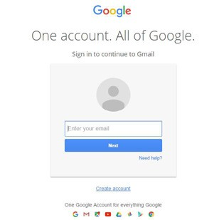

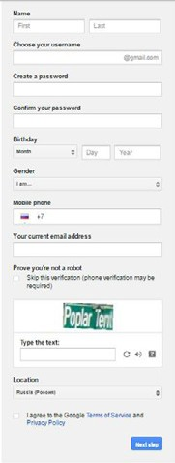
- If you do not have a Google account, you should tap on “Create account.” If you do have an account, just sign in.

After tapping on “Create account,” you are redirected to the page “Create your Google Account,” where you should fill in all necessary information.

Tap on “Next step” and confirm your account.

After receiving the confirmation, your account is created!

- Google redirects you to your homepage.

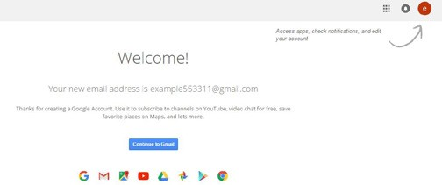

- If you tap on the red circle in the upper-right corner, you can edit your account information or change your photo.

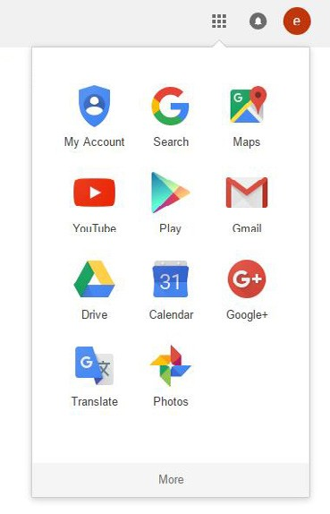
- If you tap on the square, which contains nine other squares,
in the upper-right corner, the menu of Google Apps will open. Here we can see the most usable apps. If you want to see others, you should click the “More” button.

- Tap on the Gmail icon to enter mail.

When you first open your mail, you will see a short guide on how to work with it and then how to organize your account.
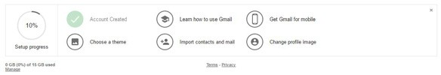

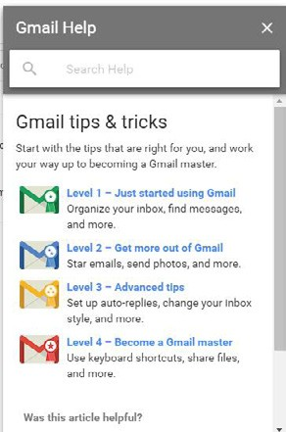
- In a few steps, you can learn how to use Gmail, get a mobile app, choose the theme, and explore many other features. If you click on “Learn how to use Gmail,” a help con- sole will appear where you can learn how
to organize your inbox, find messages, start emails, send photos, set up auto-replies, change your inbox style, and more.

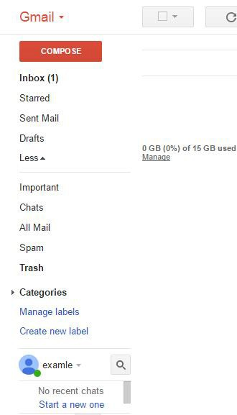
- The mail menu contains the following elements:
  - Inbox folder (contains all received messages);
  - Starred folder (contains messages which are marked with a yellow star);
  - Sent Mail (contains all sent messages);
  - Drafts (contains messages which are not sent yet);
  - Labels (you can create labels to manage your mail);
  - Hangouts (voice or video chats).

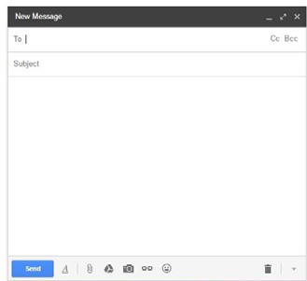
- To create an email, just click “Compose.” A new window appears for typing a message. In the field “To,” write the email of the address- ee, and in the field “Subject,” write what the letter is going to be about. Also, you can add files (from your hard drive or the Google cloud drive), links, photos, and emojis.

When you have finished the letter, just tap on “Send.”

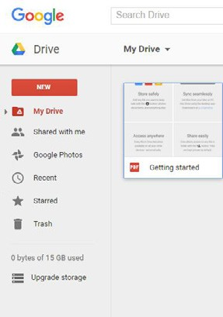
- The next step of our guide is on how to use Google Drive. Cloud starts with 15 GB of free Google online storage, so you can keep
photos, stories, designs, drawings, recordings, videos—anything. Learn more at https://www. youtube.com/watch?v=jWvKAYKlnnM.

Google Drive contains:
  - My Drive (all that you create or add to your drive);
  - Shared with me (all Docs that somebody has shared with you);
  - Recent (Docs that you opened recently);
  - Starred (Docs that are marked with a yellow star);
  - Trash (deleted Docs).

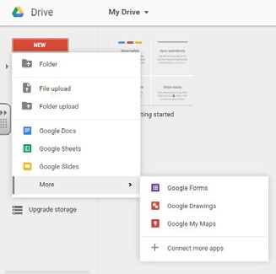
- If you want to create a folder, upload a file, upload a folder, or work with Google apps (Docs, Sheets, Slides, Forms, etc.), tap on “New” and choose what you are going to do.

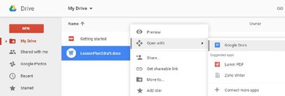
- Google Docs is a word pro- cessor. It is like Word, but you use it online. You can create a Google Doc and then download it as a Word file, and it works the same the
other way—you can upload a Word file to the Drive and convert it into a Google Doc.

As you can see, the Google Docs interface looks like Word. It is less functional, but it has some unique features nonetheless. To rename the document, just tap on “Untitled document” on the upper-left corner and enter the name you prefer.

One interesting thing is that all changes that you have done save automatically if you have an internet connection, so when suddenly the electricity blacks out you may be sure that all information is saved.

Another useful feature is Comments. You can add comments to the text, mark them as solved, or reply to the comment. Gmail informs you about all comments added by other users.

Also, Google saves the history of the document. To access it, tap “All changes saved in Drive.” You can see when and what changed in your Doc, and you can even restore an old version of the document.

All these functions work with Google Sheets, Slides, and Forms, too.

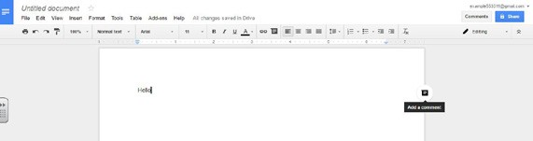

The most interesting feature in Google Docs is collaboration. You can work in Google Docs with your colleagues or friends at the same time. To organize this work, you just need to share your Doc with other people—tap on “Share” on the upper-right corner.
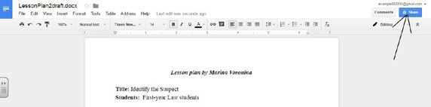

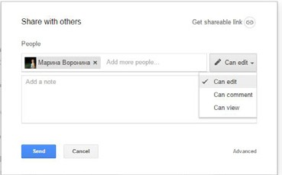
A menu with options will open. You can add people via their Google account and give them access to edit, comment, or view your Doc.

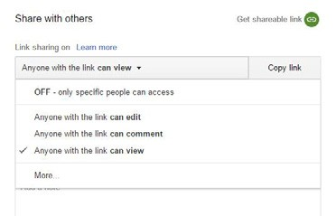
If you tap on “Get shareable link,” another menu will open, where you can give access to everyone via URL (to edit, comment, or view your Doc), so your coworkers are not required to have Google accounts.

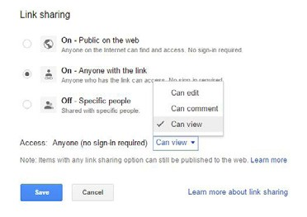
If you tap “More,” another menu will open, where you can give access to everyone on the inter- net (rights to edit, comment, or view your Doc), so anyone can find and access your Doc with- out signing-in to Google.

As you can see, there are lots of variations for collaborative work, so you can make this process more flexible. You can share Google Sheets, Slides, and Forms, too. The procedure is the same.

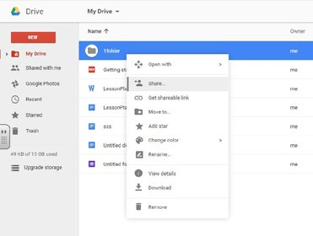
Also, you can share any files or even folders on your drive by right-clicking the file or the folder. The option menu will open, where you can share the file, move it, mark as starred, rename, download, remove, etc.

- Google Sheets is a spreadsheet application. It is like Excel, but you use it online. You can create a Google Sheet and then download it as an Excel file. The same procedure works the other way—you can upload an Excel file to the Drive and convert it into a Google Sheet.

As you can see, the Google Sheets interface looks like Excel. There is one interesting function—chat. You can see the “Chat” button on the upper-right corner before “Comments,” so if there are some people working online at the same time they can chat with each other in the Sheet.
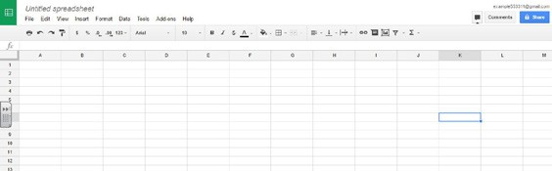

- Google Slides is a presentation program. It is similar to PowerPoint, but you use it online. You can create Google Slides and then download it as a PowerPoint file. The same procedure works the other way—you can upload a PowerPoint file to the Drive and convert it into Google Slides. As you can see, the Google Slides interface looks like PowerPoint.
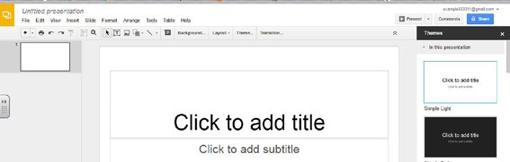

- Another interesting Google program is Google Forms. This app helps to create custom forms for sur- veys and questionnaires. Google Forms gathers everything in a spreadsheet and analyzes data right in Google Sheets.

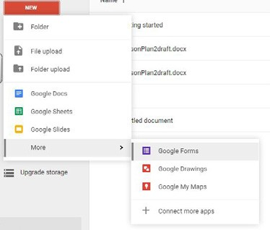
Tap “New” – “More” – “Google Forms” to create a GForm.

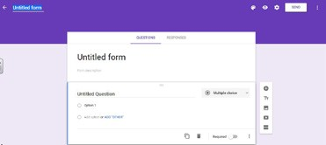
Tap “Untitled form” to rename your form.

If you want, you may add the description of the form, where you can explain to the respond- ers your expectations.

Tapping the palette on the upper-left corner opens a menu with colors you can choose to add to your form. If you tap on the picture icon on the lower- right corner, a new menu with themes will open.

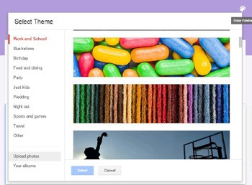
You can choose a theme that suits your style or upload your own photo or logo by tapping “Upload photos.”

Tapping the eye icon in the middle of the icons helps you preview your form.

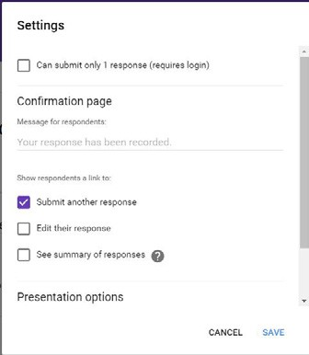
To the right of the preview button, you can see the “More actions” button, which looks like a cogwheel. If you tap the cogwheel, a settings menu will appear.

You can choose different options here and change messages for responders on the confirmation page (this page opens to responders, after they answer all the questions).

You can also add a progress bar of answers to the form or even shuffle the order of questions.

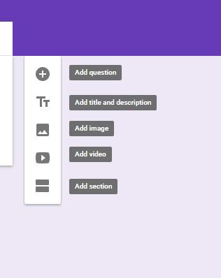
On the right part of the form, you can see the menu for editing your form.

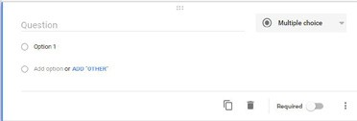
If you tap on “+” a new question will be added. There are differ- ent types of questions:
  - Short answer;
  - Paragraph;
  - Multiple choice;
  - Checkboxes;
  - Dropdown;
  - Linear scale;
  - Multiple choice grid;
  - Date;
  - Time.

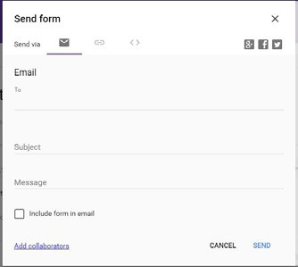
To send your form, tap “Send” on the lower-right corner.

You can send your form via email or by the link, or upload it to your blog or site using HTML.

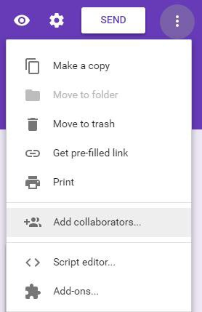
If you tap on the three vertical points to the right of the SEND button, a menu of the form will open, where you can add collaborators.

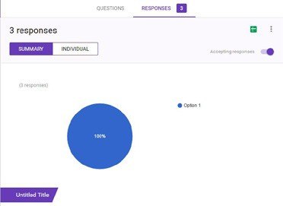
You can see a summary of all responses or view individual responses.

You can also create a spreadsheet with responses.

How to Set Up a Website

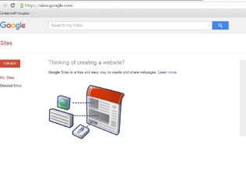
- To create your site, choose Sites in the Google Apps menu (the square, which contains nine other squares, on the upper-right corner – “More” – “Even more from Google” – “Sites”), and a new tab with the Sites menu will open (https://sites.google.com/).

To create the site, tap “Create.”

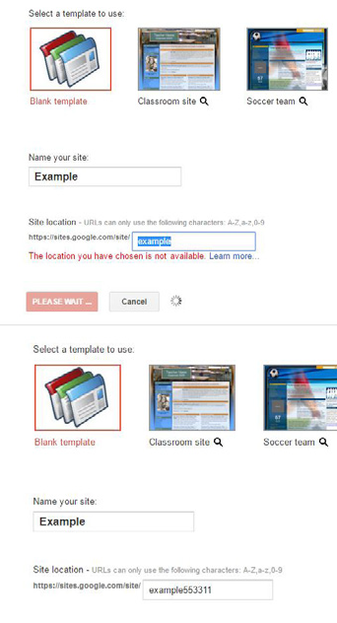
- A menu with site settings will open, where you can name your site, select a template, and choose a site location.

Note on the template: If you decide to use someone’s template, all information from the template will be automatically created on your site. Don’t forget to clear all.

Note on the location: The location will be created automatically, but you can change it, e.g., I’ve decided to name my site “Example,” but location https:// sites.google.com/site/example is not available because this URL already exists. So I can add some numbers or letters to the URL without changing the site’s name.

After finishing all the steps, verify that you are not a robot (spam protection), and tap on “Create” on the top of the page.

The Home page of the site is created automatically. To edit, rename the page, and fill it with informa- tion, tap on the “pen” icon.
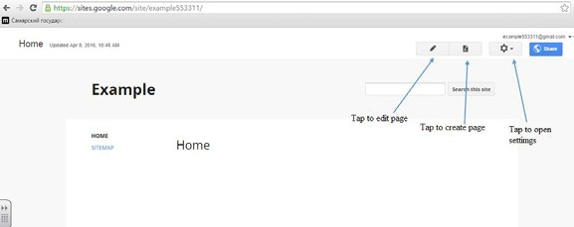

- The interface of the editing page is almost the same as Google Docs. To rename it, change the present name to a new one. To add information, start typing in the window under the page name.
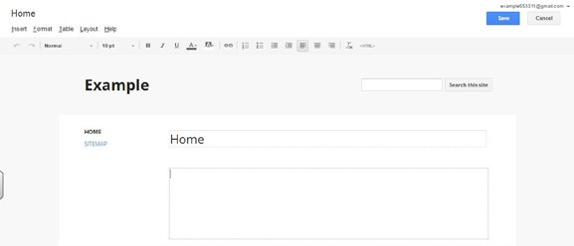

If you want to add something to your page, tap “Insert.” The menu will open, where you can choose what to insert.

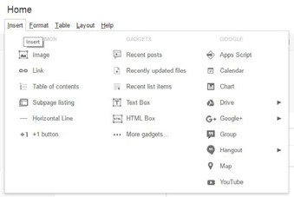
You can add:
  - Images;
  - Links;
  - Tables;
  - Lines;
• +1 button;
  - Text boxes;
  - HTML boxes (help to add different gadgets like Glogs, mind maps, learning apps, tasks, etc.);
  - Calendars;
  - Charts;
  - Files from your Google Drive;
  - Hangout buttons;
  - Maps;
  - YouTube videos.

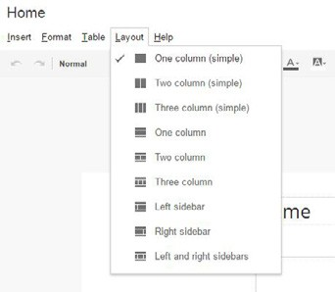
The “Format” menu and “Table” menu are the same as in Google Docs. An interesting menu is “Layout.” Browse the Layout menu and choose a different layout for every page if you would like.

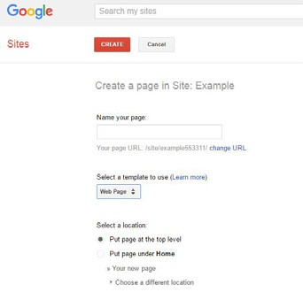
- To add a new page, tap . Then name your new page, and select a template for your page and its location.

You can find many templates for your page at https://support.google.com/ sites/answer/98216?hl=en.

After filling all the gaps, tap “Create.”

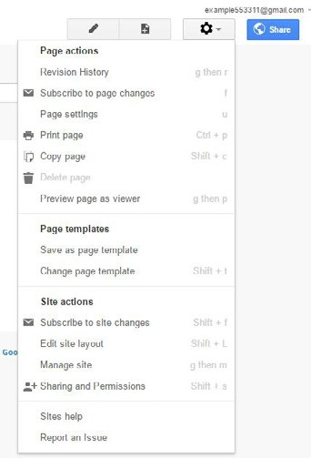
- The icon opens the settings menu.

You can change page settings such as your page title, sub-pages, attachments, and comments, and decide whether or not you would
like them to show up on each page.

You can also add a page descrip- tion, which will help Google Search find your page.

You can edit the site layout here. Note that managing the site layout here is for the entire site, not for one page.

You can enter the “Manage Site” menu and “Share” your site.

- The “Edit site layout” menu gives you access to change the site header. You can add your logo or any image here by tapping on the top part to edit the header.

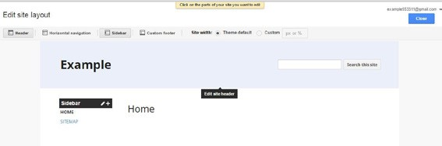
Also, here you can choose whether you need a header or not, horizontal navigation, sidebar, and footer, and set the site width.

To change the sidebar, tap on the pen icon on the “Sidebar” menu . If you tap the + icon, a menu of new items for the sidebar will open. You can add the +1 button, navigation, text, etc.

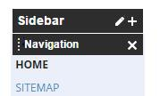
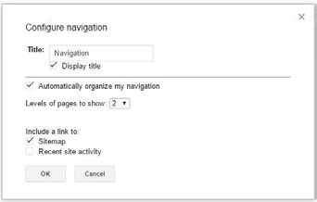
To change Navigation settings, tap the four vertical points near the word “Navigation,”
and a menu of navigation will open.

You can choose to show the title or not, to organize navigation automatically or not, etc.

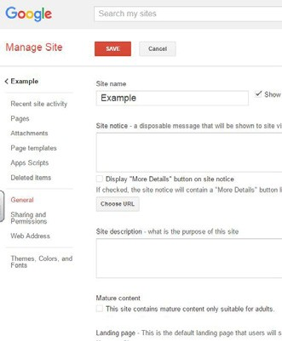
- If you choose “Manage Site” in the settings menu, the site leads you to the Manage Site page, the most useful page of the site.

On this page you can see different tabs.

On the “General” tab, you can add:
  - a message that your site will show to guests;
  - a description of your site;
  - it as an adult site, delete or copy it, choose the site display language, etc.

In the tab “Sharing and Permissions,” you can add collaborators or choose who can see your site ( just you, anyone with a link, or everyone on the internet).

If you decide to make your site public, it will appear in Google Search in a few days.

On the “Web Address” tab, you can move your site to another URL.

The “Themes, Colors, and Fonts” tab will help you to change the visualization of your site. This tab is very useful because you can change every part of the site separately from the others.

After making all the changes, don’t forget to tap “Save” on the top of the page.

How to Use and Start Google+

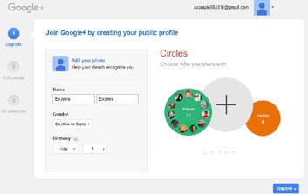
- To create your Google+ account, choose G+ in the Google Apps menu (the square, which contains nine other squares, on the upper- right corner).

A page for creating G+ will appear. You have to complete three steps.

The first step is updating your profile. G+ will automatically take you through some steps to help you update your profile.

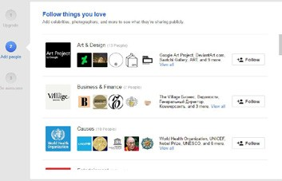
The second step is adding friends or some famous people.

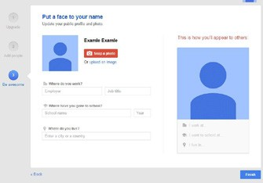
The third step is making your G+
page more interesting.

When you finish with all the infor- mation G+ guided you through, tap “Finish” in the lower-right corner of the page.

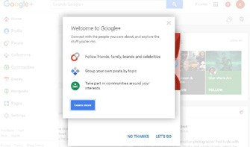
After creating your G+ page, a help window will appear. You may tap “Learn more” in order to know how to use G+.

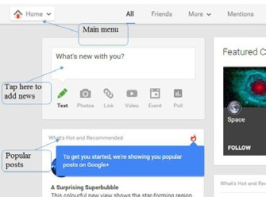
The G+ interface is simple. The “Home” tab has the main menu, which is a space where you can add your news, photos, videos, etc., and view the most popular news or your friends’ news.

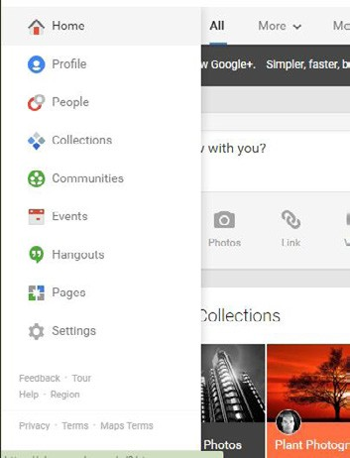
The main menu has the following tabs:
  - Home;
  - Profile;
  - People;
  - Collections (you can group your posts here by topic);
  - Communities (you can create or participate in different communities);
  - Events (you can create or participate in different events);
  - Hangouts (text, video, or audio chats);
  - Pages (this app works with business accounts—they are paid);
  - Settings (you can manage your G+ activity here).

How to Use and Start Twitter

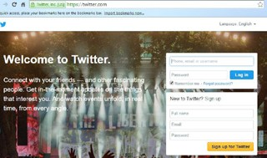
1) Put twitter.com in the browser address bar. The window with your Twitter account will open.

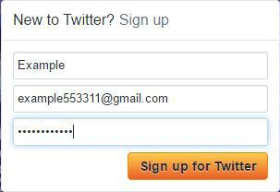
If you don’t have a Twitter account, sign up by filling in the empty fields. Then, tap “Sign up for Twitter.”

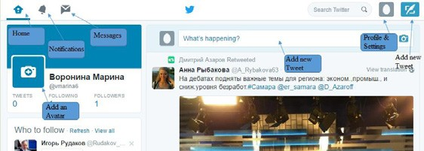
The home page is rather simple. To add a new Tweet, you can enter information on the empty line or by tapping the “Tweet” icon. There are also different settings that you can change depending on your preference.

How to Use and Start Vkontakte and Facebook

- VKONTAKTE
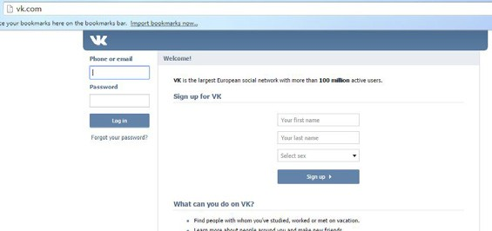
Put vk.com in the browser address bar. The window with your Vkontakte (VK) account will open. To prevent your Center account from being banned, I recommend you create your own account and then add an Academic Writing Lab/Center community. If you have your own VK account, log in and create a community. If you don’t have a VK account, sign up and create a community.

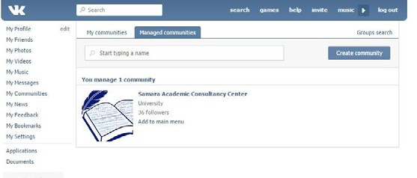VK is a social network where you can communicate with people. The interface is rather simple. The main menu is on the left of the page, and you can manage everything from here. To create your commu- nity, tap “My Communities” in the main menu, then tap “Create community” on the upper-right corner of the page.

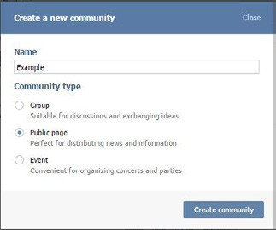
A menu for creating a new community will open. Give a name to your commu- nity and choose its type.

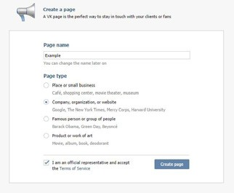
After that, a “Create a page” menu will open. This is where you can choose the type of your Main page and create the page.

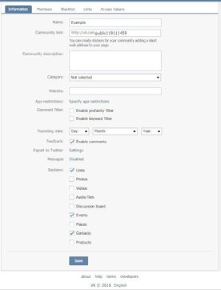
After creating a page, you can add some information about your community, add members, add links, etc.

In the “Members” tab, you can give adminis- trator rights to other members of your com- munity.

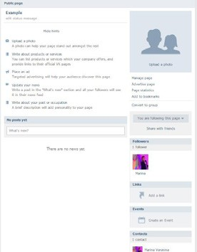
After all settings are done, your page is ready. You can upload photos, update your news, add posts, add followers, create events, etc.

- FACEBOOK
Put facebook.com in the browser address bar. The window with your Facebook account will open. To prevent your Center account from being banned, I recommend that you create your own account and then add an Academic Writing Lab/Center group. So, if you have your own Facebook account, log in and create a group. If you don’t, sign up first and then create a group.
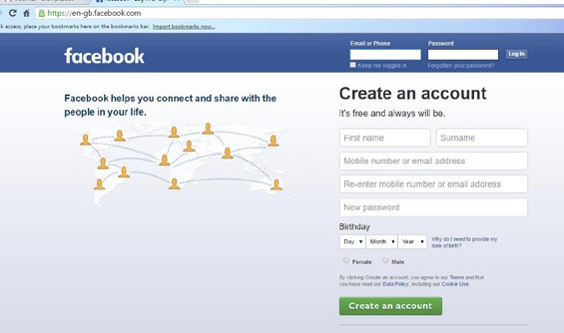

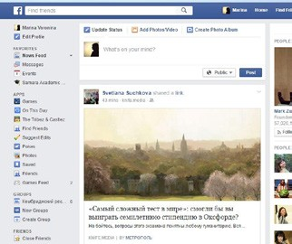
Facebook is also a social network where you can communicate with people.

The interface is rather simple. The main menu is on the left of the page. It allows you to manage everything.

To create your group, tap “Create Group” in the main menu.

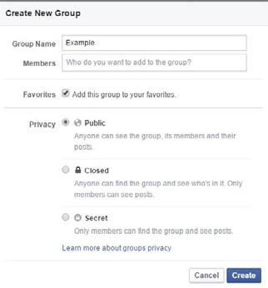
Next, a “Create New Group” page will open.

You can name your group here, add members, and choose a privacy setting.

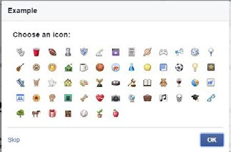
Don’t forget to choose the group icon.

This icon will be on the main menu.

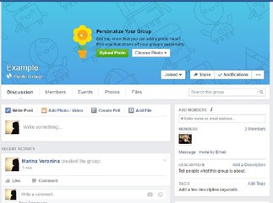
Your group page is created. You can write posts here, personalize your group, add photos or files, and create events.

To manage members, tap “Members.”
Here you can add members and give them the rights of a moderator to ensure you have more than one moderator.

How to Put Writing Center Activities on Your University Website
At our university, we send the university IT services our news via email, and they post the information to the university site.
You can change the link of your site to “yourcenter.youruniversity.com.”
To organize it, visit Google support at https://support.google.com/sites/answer/99448?hl=en and your IT service. After all requirements are made, you can add your new URL in the Manage Site menu’s “Web Address” tab.
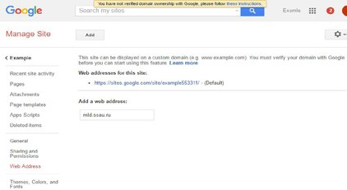

Sample Webpage Information
The following sections have been taken directly from Samara Academic Consultancy Center’s website.
They are copyright free and can be modified to fit the needs of your institution.
The first section, entitled “Welcome,” is the main page of the website. It describes what a person can expect from the writing center. The audience is the institution’s general community.

The second section, entitled “FAQs,” is a section that answers frequent questions that the academic community might have about the writing center. In this section, the author has left the word “NAME” in capital letters. If you decide to use this to help start your website, replace the word with the title or name of your writing center.

Welcome
The Samara Academic Consultancy Center is a place for members of the Samara State University and the Samara State Aerospace University to get help with their writing. The English Writing Center is staffed by trained tutors from the English department of both universities who provide individual consultations to faculty and students working on any piece of writing.
Having a finished product is not necessary to come to a consultation. You are welcome to bring brain- storming notes, an idea, an outline, notes, or a draft. For further information, please read our answers to

frequently asked questions (FAQs).
Rules: In order to ensure that each member of the Samara State University and National Aerospace University community has an equal opportunity to participate in and receive good-quality consultations, the writing center will adopt the following policies:
  - Each tutee can only book one appointment per day.
  - Each tutee can only book two appointments per week.
  - Each consultation lasts for 40–60 minutes.

FAQs
Do I have to pay for an appointment?
No. Appointments are free for all faculty and student members of the university system in Samara.

When is the NAME open?
Consultations are currently based on tutor availability. Please check the schedule online for availability.

How do I make an appointment?
You can fill out an online form or send us an email.

Who goes to the NAME?
Any member of the university community who wishes to have good feedback on a piece of his or her writing! We understand that you may not have a draft ready.

We can also help you with your ideas for your article or paper.

What will a consultation do for me?
A consultation will help you to see the areas of your writing that may not be communicating as effectively as you would like them to. You are welcome to ask for feedback on content, meaning, and readability. Have a journal article idea and need someone to bounce ideas off of ? A consultation is a place for you to work with a tutor to come up with ideas or outlines for articles.

What is a writing consultation like?
Questions, questions, questions! A consultation is you with a tutor discussing your work through a series of questions and answers. Come with your questions ready for the tutor and get the most out of your expe- rience.

What do I need to take with me to a consultation? We work with writers during any stage of their writing process. In other words, bring your journal
description, your assignment instructions, your ideas, questions, notes, and the results of brainstorming sessions. If you have a draft, print it and bring it with you or bring your laptop. We cannot accommodate flash drives.

Will the tutors correct the grammar mistakes on my paper?
No. If you ask, tutors will point out areas on your paper where you have made grammar or syntax mistakes; however, they will not correct them. They will help you find resources to help you understand your grammatical errors so that you can continue to improve your writing.

Will the NAME check my grammar?
See above.

Can the NAME help me with my CV/resume? Absolutely. You might also like to sign up for a CV/ resume and cover letter workshop.

See Handout 7: Sample Webpage Information for worksheet.

Writing Center Website Creation Questions

  - Who will design the website?
  - How will the website be maintained (i.e., who will update the website and fix any problems)?
  - How will the writing center use the website?
  - How will the writing center use social media? Who will update the events or activities on social media? How will the social media accounts be updated?

See Handout 8: Writing Center Website Creation Questions for the printable worksheet.

63

WRITING A WRITING CENTER HANDBOOK

A writing center will run successfully year after year if it has a clearly defined administrative process and roles for all members. Often, the administrative pro-
cess is kept in a handbook. This is helpful because the roles of the director and tutors will be clearly stated. A clear definition of roles allows tutors to understand their duties and what is expected of them in the work- place. A handbook is also helpful because if a writing center director or tutor is no longer able to fulfill his role, another person can be chosen to fill his place
and follow clearly outlined guidelines. In this way, if a director leaves, the new director will understand the role while being prohibited from making any sudden changes that would upset the work flow of the writing center.
If you have been answering the questions in this workbook, you will have already written much of your handbook! Transfer your responses onto a document, and you are ready to go.

Policies and Procedures

Hiring a tutor
Every writing center will have different procedures when it comes to hiring tutors. At the Samara Academ- ic Consultancy Center, we held 13 weeks of lessons
in writing center methodology and writing. These lessons included two practice tutorials where the tutors-in-training wrote an essay or journal article and then practiced consultations. For the first consultation, it was the first draft of their paper. They then made changes, and the second consultation was on the sec- ond draft of their paper. For each consultation, the tu- tors wrote what went well during the consultation and what they would like to do better the next time they gave a consultation. This is an important step for the
tutors to begin to practice reflection. As a tutor, you will always be challenged to improve how you give a consul- tation, and it is important to consider what you thought went well and what you know can be improved.

During the 13 weeks of lessons, they were also required to watch me as a Specialist give consultations to researchers and postgraduates from Samara Nation- al Research University. The tutors-in-training then wrote a short reflection on what happened during the consultation and how they might adapt the style to use during their own consultations.
Finally, in order to be chosen to work in the writing center, the tutors-in-training submitted a writing portfolio. This portfolio included: 1 final essay or journal article; 2 rough drafts; 2 reflections on the tutor-in-training’s experience as a tutee; 1 reflection on the observation of my tutorial; a personal statement addressing why they would like to be a tutor; and a statement about what they learned about the role of a tutor. If the portfolio was strong, the tutor-in-training was invited for an interview and tutor role-play. Below

is the form used to evaluate the tutors-in-training during the role-play.
The SACC Tutor Role-Play Rubric Evaluation
might also be used for tutor observations once a month for professional development purposes and to maintain quality control.

SACC Tutor Role-Play Rubric

 | Poor | Fair | Good | Excellent
Communication | Often had difficulty explaining concepts. Lost patience with tutee. Did not listen to the concerns of the tutee. | Sometimes had difficulty explaining concepts. Some- times lost patience with tutee and usu- ally listened to the tutee’s difficulties and concerns. | Explained concepts clearly and concise- ly. Listened carefully to concerns of tutee. Showed patience in repeating instruc- tion until tutee understood. | Explained concepts clearly and precisely. Used own examples and methods in attempting to help tutees understand. Lis- tened carefully to the tutee, and persisted in helping the tutee until the concepts were under- stood. Provided motivation for the tutee to learn.
Energy and Attitude | Rarely smiled and gave encouragement to tutees. Tutees were hesitant to approach tutor. | Helpful to tutees but did not provide a lot of energy and en- thusiasm by asking questions, clarifying ideas, or eliciting more discussion. | Usually positive, helpful, energetic, and enthusiastic. Asked questions, clarified ideas, and elicited more discussion with  tutee. Put tutees and other tutors at ease by making them feel welcome. | Always positive, helpful, ener- getic, and enthusiastic. Asked questions, clarified ideas, and elicited more discussion with tutee. Put tutees and other tutors at ease.
Engagement | The tutor lacked fo- cus in the consulta- tion, often distracted by the surrounding environment. The tutor seemed dis- interested and did not interact with the tutee. | The tutor was some- times distracted by the surrounding environment, but was able to keep focused and interact with the tutee a  large portion of the time. The tutor  was sometimes able to ask thoughtful questions and make clear restatements that demonstrated understanding of most of the concepts discussed. | The tutor was dis- tracted 1 or 2 times by the surrounding environment, but was able to keep focused and interact with the tutee for a majority of the time. The tutor was able to ask thoughtful questions and made clear restatements that demonstrated an understanding of most of the concepts discussed. | The tutor demonstrated engagement in the tutoring session by ignoring other activ- ities in the center and focused on the session. The tutor consistently asked thoughtful questions and made clear re- statements that demonstrated understanding of most of the concepts discussed.

 | Poor | Fair | Good | Excellent
Feedback | Focused on mistakes in grammar and spelling. Made no comments on the structure of the paper. If grammar was interfering with the meaning, did not explain why. | Mainly focused on mistakes in gram- mar and spelling; however, made a few comments on the structure of the paper. When  grammar interfered with the meaning, the tutor sometimes explained why and asked tutee to find other examples in her writing. | Made comments on the structure of the paper or areas where meaning was not clearly com- municated. When grammar interfered with the meaning,  the tutor sometimes explained why and asked tutee to find other examples in his writing. | Mainly focused on the structure of the paper or areas where meaning was not clearly communicated. When grammar interfered with the meaning, the tutor explained why and asked tutee to find other examples in her writing for her to correct.
Facilitation | Tutor dominated the session by talking or writing too much. | Tutor had a tenden- cy to dominate the session by talking or writing too much. | Tutor mainly fo- cused on the needs of the tutee by ask- ing what he would like to focus on and explaining the pro- cedures of a tutorial whenever it was the tutee’s first time. Tu- tor asked questions (open-ended and directive, depending on the needs of the tutee). Asked tutees to do most of the writing. | Tutor focused on the needs of the tutee by asking what she would like to focus on and explaining the procedures of a tutorial whenever the tutee was there for the first time. Tutor asked questions (open-ended and directive, depending on the needs of the tutee). The tutees did all of the writing.

See Handout 9: Tutor Role-Play Rubric for a printable rubric.

Center Creation Questions: Hiring a Tutor

- What procedures will you use for hiring a tutor?
- How will you adapt the rubric for your own needs?

See Handout 10: Hiring a Tutor for a printable worksheet.

Tutor Consultation Evaluation
This next form is used by the tutee at the end of the consultation. One or two minutes should be left at the end of the consultation for each tutee to take time to write about his experience and offer areas for im- provement. While the tutees complete an evaluation of the consultation and the tutor, the tutors should
be writing their own evaluation of the session. Each evaluation should include what was covered during the session and the action plan that the tutor and tutee

have agreed upon before the tutee’s next visit. This action plan includes all the parts of the paper the tutee will change and/or any grammar activities he will prac- tice before the next consultation.
There are many sample forms for both the tutor and the tutee to use online. Below is an example of a form that tutees will fill out about their experience. Feel free to use the form and change whatever you need to suit the needs of your center.

Sample Tutee Evaluation of Consultation and Tutor

Date: Tutor Name: Department:

1) During our session, my tutor and I worked on:

☐ | Abstract | ☐ | Citations | ☐ | Grammar
☐ | Thesis Statement | ☐ | Argument | ☐ | Articles
☐ | Paper Structure | ☐ | Paragraph Development | ☐ | Other:
☐ | Research | ☐ | Introduction | ☐ | Other:
☐ | Word Choice | ☐ | Outline | ☐ | Other:
2) | Rate your experience:
I have a better idea of what I should do to make my paper better.

1
Disagree
2 3 4 5
Agree

The writing tutor worked to help me clearly express my ideas.

1
Disagree
2 3 4 5
Agree

The writing tutor was patient.
1
Disagree

2 3 4 5
Agree

The writing tutor asked me questions about my ideas.

1
Disagree
2 3 4 5
Agree

3) What was the most helpful? Why? What suggestions do you have to improve your session?

See Handout 11: Sample Tutee Evaluation of Consultation and Tutor for a printable and modifiable version of this evaluation.

Tutor Workshop Evaluation
At the Samara Academic Consultancy Center, it was required for each tutor to run a workshop for the academic community once every six weeks. This schedule allowed us to have one workshop every week while making sure that the tutors had time for their consultations and for planning their next workshop. Since there is always room to improve workshops,
the tutors would practice them with other tutors, who would give feedback. The feedback generally included ideas on making the workshops as student-centered

as possible—the presenter should be giving short instructions then allow the participants to practice whatever the topic was about. The presenter answers any questions that the participants might have, but this structure frequently means that the presenter is speaking for 5 minutes or less during a workshop.
Tutors are observed once a semester to receive feedback on becoming more student-centered. The following is a possible rubric that could be used during these observations.

Tutor Workshop Rubric
Abbreviation:
Ppt = PowerPoint

 | Poor | Average | Good | Excellent
Structure | Absence of struc- ture or organiza- tion. Presentation is unclear and difficult to follow. | Introduction and/ or conclusion may not be clear or may be missing. Presen- tation is somewhat unclear and difficult to follow. | Clear beginning and end, but the presentation some- times lacks clear transitions. | Clear beginning, middle, and end, with an aim that is clearly stated and maintained throughout.
Presentation Skills | Practically no eye-contact, looks indifferent, or speaks at the  audience. Makes a variety of pronun- ciation mistakes, speaks too softly or loudly. | Looks a little detached, little eye-contact with  the audience. Does not annunciate/ mumbles or has no volume control. | Stands up straight, makes eye-contact for a majority of the Ppt. Speaks clearly and distinctly, though may have 1–3 words mispro- nounced. | Stands confident- ly, looks relaxed, and maintains  eye-contact with the audience. Speaks clearly and distinct- ly. Enthusiastic and no mispronounced words.
Learner-centered | Facilitator speaks most of the time and does most  of the activities. Content is not stim- ulating and does not require partici- pants to respond or engage. | Facilitator speaks a majority of the  time. The activities are arranged so that the facilitator has to tightly control them. | Activities and presentation are organized in a way that focuses on participant engage- ment. | Activities and presentation are organized in a way that focuses on participant engage- ment. Learning reveals feelings and thoughts of partici- pants.
Outcome | The outcomes are not defined and it is difficult to figure them out from the Ppt and activities. Or, the outcomes are not manageable within the given time frame. | The outcomes are somewhat clear but many aspects of the Ppt and activities seem only slightly related. Or, there are either too many or too few outcomes. | The outcomes are given but the pre- senter occasionally wanders from that focus. It is not clear that all outcomes will be achieved  by the end of the presentation. | Defines manage- able outcomes for the Ppt and  activities clearly at the beginning and maintains this focus throughout. Checks whether or not the outcomes were achieved at the end of the Ppt.

 | Poor | Average | Good | Excellent
Timing | Presentation is 5–6 min longer or shorter. | Presentation is 3–4 min longer or shorter. | Presentation is 2 min longer or shorter. | Exactly 25 min.
Slide Content | Only textual infor- mation, overload- ed with text, not readable, small font, noisy background. | Small font, inappro- priate background, slides sometimes overloaded with text. The informa- tion is useless; text of the workshop does not always correspond with the speaker. | Mostly appro- priate size of text and integration of photos or other visual stimulants. 2–4 slides might not match. Text almost always corresponds with speaker. | Appropriate size of text, integration of photos or other visual stimulants. Stimulating. Text perfectly corre- sponds with the speaker.

See Handout 12: Tutor Workshop Rubric for a modifiable rubric you can use.

Internal Problem Solving
Also included in the Policies and Procedures section of your handbook should be a section on professional- ism. In this section, the handbook should outline the day-to-day duties of the tutors and how the adminis- tration will deal with inappropriate behavior.
A typical day for tutors includes at least six duties, though this varies from writing center to writing center.

Duty 1: Responding to emails on behalf of the writing center
Emails come from a variety of sources. Some emails will be inquiries into the writing center and what it is, while others may be asking about an up- coming event. Writing center tutors need to know all the upcoming events and what website or document to send to meet people’s inquiries. For example, the writing center receives the following email:

Subject: What’s Your Purpose? Dear Writing Center,
I think I want to visit, but I don’t know your purpose and I don’t want to waste my time. I’m working on a paper for a conference and need some advice. Is this something that you can provide, or are you simply an editing service?
Thanks in advance for your response.
All the best, John Doe
The tutor on duty the day the email is received might respond by writing:
Subject: RE: What’s Your Purpose? Dear John Doe,
Thank you for contacting the writing center. We appreciate your interest in our services.
We are not an editing or proofreading service. During a consultation, we will read through your paper and offer suggestions on areas of the paper that you would like assistance with. Basically, you might think of us as a fresh set of eyes or sounding board off which to bounce ideas.
Attached is a document entitled “Overview of Services.”* This document describes what the writing center offers in further detail. If you have further questions, we would be happy to answer them.
If you would like to make an appointment for a consultation, you can sign up at (insert URL).
We look forward to working with you.
All the best,
XYZ Writing Center
*A sample “Overview of Services” is provided on page 91.
All writing center tutors should be aware of and able to answer questions about all writing center activities and plans.

Duty 2: Checking and approving appointments Once the writing center administration has decided on an effective scheduling software and procedure, the administration should choose if they would like to designate one tutor to manage the schedule or allow all the tutors to manage the schedule. Either way, someone must check daily and approve appointments. This consists of writing them into the online schedule and contacting the tutee to confirm the appointment and ask for any relevant documents.
Fortunately, technology has improved to make scheduling less cumbersome. There is scheduling software that can manage the schedule for you. The way that the software tends to work is that either the tutor or tutee can cancel an appointment, but no one has to approve or enter them into a document be- cause the software completes this function. In some cases, a Director and Associate Director can access every tutor’s schedule, but individual tutors would only see their own schedules when logging in to the system. When students log in, they can see a calendar with all available appointments and the names of the tutors available for each time slot. Clicking on the tutor’s name brings up that person’s background, the languages that tutor works in, a bio sketch, etc. Sched- uling software is for sale online, but if your university has an IT department, they might write the whole program. This ensures that the program is tailored to the specific needs of your writing center and that you can change elements of the program as you go.
A standard practice for all writing centers is to ask that the tutee provide, 24 hours in advance, her paper or draft; the guidelines of the assignment or journal; and 1 or 2 papers that have been published in the journal in which she wishes to be published. This allows the consultant/tutor to review and prepare the information ahead of the consultation. I personally allow myself 1–4 hours of prep time for each consul- tation. The amount of prep time needed depends on the consultation. If it is a science paper of a field that is unknown to me, I will do some research on the topic of the paper so that I have a better background in which to ask meaningful questions. Not all writing centers require this type of background research. It is up to the administration. In your first year of working as a writing center, this might be something that is discussed between all writing center staff and agreed upon.

Duty 3: Writing or conversation consultations During a tutor’s scheduled work time, he is responsi- ble for handling any walk-in requests for consultations and the scheduled consultations.

Duty 4: Paperwork
The tutor should write summaries of all consulta- tions she held during her working hours. It would be very useful to have a form that all tutors fill in to
standardize the process. By recording the information about the consultation, the tutor has the opportunity

to reflect on what went well during the tutorial and what might be improved. They are also documenting what was covered in the session so that when the tutee returns for another appointment, the tutors might read their notes and remind themselves of what was cov- ered. Or, if the tutee is meeting with a new tutor, that tutor might read what was discussed and understand where to begin during the consultation.

Duty 5: Workshop / handout creation
During the first few years of the writing center, the tutors will be very busy with creating student-cen- tered workshops and handouts. The student-centered workshops will cover a wide variety of topics. The easiest way to start creating workshops is to focus on common writing problems exhibited by your institu- tion’s writing center clients. It is advisable to focus on only one problem per workshop. During the work- shop, the tutor should introduce the solution to the problem in a way that includes the participants. The participants should then practice for the remainder of the workshop, with the tutor helping individuals when
needed and observing the group. The less the tutor talks and the more the participants practice, the better. I always aim for 95% participants, 5% me.
The handouts that the tutors create are of a wide variety. Firstly, the tutors will create handouts to coincide with the workshops. Secondly, the tutors
may create handouts of practice activities for common grammatical or writing errors. Monthly meetings to plan the development of handouts and workshop materials would be highly beneficial.

Duty 6: Semester-by-semester planning
At the end of each semester, tutors and administra- tors should meet and plan the next semester. This planning should reflect the lessons learned from the evaluations and documentation collected about the workshops and consultations during the previous semester. This will inform tutors what workshops they might work on developing during the break or coming semester. The analysis of these evaluations will also show the writing center staff what type of training they should schedule for the coming semester.

Writing Center Logistics
- What is the writing center going to be called?
- Where is the writing center going to be? How big will it be?
- How many tutors will you have? How many hours will each tutor work?
- How many administrators will you have? How many hours will administrators work? Will they also have teaching duties? Will they have consulting or tutoring duties? If so, how will their various writing center duties be balanced with their other duties?
- What resources will you have access to?

- What will be the writing center’s hours of operation?
- What data will be included in a consultation evaluation?
- What forms will the tutor and tutee use after each consultation?
- How will workshops be structured?
- What types of services will you offer (in the short term, mid-term, and long term)?
- What won’t the writing center do?
See Handout 13: Writing Center Logistics for a print- able version of these questions.

TRAINING AND DEVELOPING STAFF

Training
You are encouraged to purchase two major books dedicated to effective consultation practices: Chris- tina Murphy and Steve Sherwood’s The St. Martin’s Sourcebook for Writing Tutors and Leigh Ryan and Lisa Zimmerelli’s The Bedford Guide for Writing Tutors. These books present key strategies for a consultation. It is advisable to create your tutor- training workshops around the strategies identified
in the books. All tutors should be trained on the struc- ture of the tutorial and how to interact with the tutees.
Your training sessions will always depend on the needs of your tutors. In addition to training tutors in how to structure a consultation, you might consider

providing a refresher course on how to write an aca- demic paper in English. This course might ask them to write a scientific paper in an area that is familiar to them in order to help immerse them in the writing process and what it feels like to be a writer. This is important to develop the tutor’s empathy towards the tutees he will be working with. The trainings might also include some fun short workshops on common mistakes. The reason we would ask the tutors to participate as audience members to writing center workshops is so that they can experience the structure of a writing center workshop and what it feels like to be a participant.

Developing Staff
Staff should be encouraged to take an active role in their development as a writing center tutor. Many cen- ters will have a series of courses they offer their staff to develop their skills as writers and tutors. Writing cen-

ters are also wonderful places to participate in action research, which might be presented at international conferences.

BEST PRACTICES IN DEVELOPING AND SUSTAINING YOUR WRITING CENTER

The Consultation

Basic Writing Center Methodology and Principles for Working with Tutees

Focus on the writer: In the pivotal article “The Idea of a Writing Center” (1984), Stephen North explains that writing centers must define themselves in terms of the writers they serve. They do not exist solely for faculties or departments, but for the development of writers. This means that the writing center must cater to the writer’s needs. Since the tutees come from a
wide variety of faculties or departments, it is important for the consultant to assess the needs of the tutees and engage them in “writer-centered” consultations.

Focus on process rather than product: Instead of focusing on a completed product, the writing center helps tutees see writing as a process and encourages them to improve as writers. Obviously, a consulta- tion should improve the specific piece of writing a tutee discusses with the consultant, but the main goal should be long-term growth. Focusing on process helps tutees understand and adapt their ideas about writing and who they are as writers (Warnock and Warnock 1984). This is one of the reasons that tutees leave every consultation with an action plan of steps they have to take to improve their writing before
the next consultation, or before it can be sent to a publisher.
Respect tutees by encouraging them to retain own- ership: Ask tutees about their concerns and progress with the particular pieces of writing they bring and their experiences as writers as a whole. As a consul- tant, this helps us to do a quick needs analysis and offer guidance on the writing process if needed. This also helps us to focus on the tutee and ensure that the consultation is “writer-centered.” By having writ-
er-centered consultations, the consultant can ensure that the writer establishes authority from the begin- ning of the consultation. This helps tutees maintain control of their writing and understand their role in the consultation as the writer expert (North 1984). This is important because it helps set the tone of the consultation and enforces the idea that the writing center is not an editing or proofreading service.

Collaboration: Writing consultants and tutees should work as equals, sharing ideas and coming to answers together. This frequently means that the “teacher” part of us must step back and allow the tutee to fully express thoughts and ideas without interruption and without our filling in the answer. Though the consultant may be more knowledgeable about certain aspects of writ- ing, it is often true that the tutee is more knowledge- able about his or her subject matter or other aspects

of his or her writing process. In collaboration, both consultant and writer learn, and the writing center be- comes a place of knowledge creation (Grimm 1996).

A place to talk about writing and share with an audience: The writing center provides a setting where tutees can share their work and receive feedback
from someone other than their colleagues or instruc- tors. Because of the unique relationships this setting creates, a number of things can happen in the writing center that may not happen in the classroom—engag- ing, honest, and open discussion about ideas; reduced anxiety; and translation of academic language to everyday language (Harris 1995).
Comfortable, welcoming environment: Writing centers greatly value community. Because of this, the writing center attempts to create a welcoming environment, a space where tutees want to be.
Whenever possible, they should look different from a typical classroom environment. For example, they may use round tables so that there is no “head”
of the table. If it is possible, get a sofa for tutees to relax on before or after their consultation. (At the Samara Academic Consultancy Center, we had a tea station that had cups, hot water, and some small snacks for the consultants and tutees. You might also consider decorating for holidays to make the center more festive and relaxing.)

Practices for the Writing Consultation
You are encouraged to purchase two major books dedicated to effective consultation practices: Chris- tina Murphy and Steve Sherwood’s The St. Martin’s Sourcebook for Writing Tutors and Leigh Ryan and Lisa Zimmerelli’s The Bedford Guide for Writing Tu- tors. These books present key strategies for a consulta- tion. It is advisable to create your tutor-training work- shops around the strategies identified in the books.
Below are just a few key strategies for a consul- tation. We highly recommend reading the books for further ideas and to deepen your understanding of the possibilities of a writing center consultation.

Establish rapport: Try to build a relationship with students before you begin working on their writing.

Introduce yourself and ask the tutee’s name, ask how he is doing, and talk about the weather or whatever subject that might come up that may make the tutee feel more comfortable. It is important to establish a sense of comfort at the beginning of the session so that the tutee feels that she is sharing her work with someone who is nonjudgmental.

Goal setting: Goal setting should occur after estab- lishing rapport, near the beginning of the session. The consultant typically asks questions like, “What are you working on today?”; “Where are you in the process?”; or “What are you concerned about?” This helps
the consultant understand where the tutee is in the writing process and what her concerns are. Next, the

tutor and tutee can agree upon realistic goals for the session. Have the tutee write her goals on a scrap sheet of paper or at the top of her piece of writing. Halfway through the tutorial, the tutor and tutee might revisit the goals and see what has been completed and wheth- er or not they should move to another goal. Finally, at the end of the session, the tutor and tutee should go through all the goals and check off all that were com- pleted. The tutor should write the goals on a writing center form along with what was covered during the consultation. This form should go in the tutee’s file so that if the tutee returns, another writing center tutor can review the form and know what the tutee covered in the previous consultation.

Reading (aloud): After setting goals for the session together, choose sections of the tutee’s work to read. Depending on how long the piece is, it might make more sense to read all or part of the writing before discussing it. Reading the text aloud is often helpful in getting both tutee and consultant actively involved. Ask the tutee to read the work aloud. She might hear things that she may want to change. Ask the tutee to mark when she has stumbled over a section of her
writing. This frequently means that the sentence is too long or not formatted appropriately.

Strengths and weaknesses:
Strengths: Pointing out weaknesses and areas for improvement comes naturally in the writing center, as tutees visit to receive feedback and improve their
writing. However, tutees also need to know where they’re doing well as writers. Note effective passages, techniques used, and successful revision attempts.
- In addition to building confidence, this can also help students recognize their strengths as writers and see how they can capitalize on those strengths.
- You can also use tutees’ strengths to chal- lenge them to move to another level. For example, you might say, “You seem to have mastered the simple sentence structure. How about we try something a bit more complex?”
- Encourage students to take risks; be their receptive audience. For example, you can challenge them to rewrite a section of the pa- per that received no revision suggestions from the professor, deviate from the established format (the paragraph may not always have a discernable topic sentence, but the point is clear), mix styles, use active voice, or employ a new sentence structure or word.
Weaknesses: Prioritize the issues to be addressed. Ex- plain to the student that you notice a few areas of con- cern and the order in which you’re going to address them. Content-related issues, such as focus, logic, organization, and development, are considered higher order concerns and are usually addressed before style and grammar.
Students’ common issues and possible ways to address them in a session:

- Poorly formulated thesis: Begin with the assignment requirements. Check how well the student understands the task(s). If both of you are unsure, encourage the student to contact the professor. If there is no specific question in the assignment, ask the student to formulate one.
  - Socratic questioning for formulating a thesis may look like this: What question does your thesis answer? Is
it debatable (relevant in argumentative writing)? Is it too broad? Is there room for a thesis plan that would let the reader know the unique directions of the essay?
- A thesis is present but not supported: You could ask the student to highlight the thesis and then go through several or all body para- graphs asking whether and, if so, how they relate to the thesis.
- The essay is poorly organized: Reverse outlining: ask the student to record the main idea of each paragraph. If the same idea is repeated, the paragraphs where it is found can be joined or placed in the same section of the paper. Apples with apples, oranges with oranges.
- Poor grammar or style: A useful technique to address grammatical and stylistic issues is to ask the tutee to read out loud. You can ask him to stop every time something doesn’t sound
right. If the tutee can identify the error, great! If he can correct it, even better! If the tutee doesn’t see the problem, you can point to it and provide a chance to make the correction. If he can’t, you can explain what the problem is, the rules, etc. Then, you can ask the tutee to highlight or underline other areas where this problem occurs and correct a couple of such instances to ensure that he understands the rules and to see if there is anything that you need to clarify. Correction of the remain- der of these errors might be the first item on the action plan for the tutee after leaving the consultation. Help the tutee to isolate patterns of error (using a highlighter or simply point- ing to the most common errors or tendencies) and then discuss ways to deal with each
one. If there are multiple error types, do not discuss them all in a single session. This will seem overwhelming to the tutee.
  - When possible (usually toward the end of the session), observe the tutee’s general tendencies and articulate them (“You tend to write very long sentenc- es. It’s great that you’re taking this risk, but it means that you need to pay close attention to how balanced and grammatically correct your sentences are. For example, you have a couple of mixed constructions and issues with parallel structure...” You can also em-

phasize sentence variety in this conver- sation. “Let’s look at an example of a mixed construction: When the country elects a president is the most important responsibility in a democracy.”).

Nondirective/Directive continuum: Much schol- arship argues for consultants to use primarily non- directive strategies. In recent years, however, writing center scholars and practitioners have begun to discuss the use of directive and nondirective strategies as a continuum. Ideally, consultants could always use nondirective strategies, guiding students in learning rather than directing them. But at times, providing the student with more guidance may be necessary (i.e.,
if a tutee is using MLA format for the first time or if there is English vocabulary she simply doesn’t know yet). Learning how and when to be nondirective or directive is challenging and will likely vary from tutee to tutee, but being aware of your options is helpful. After time and practice, you’ll find that making those decisions becomes easier.

Respect tutees’ ownership of their work—no or minimal writing on tutee’s papers: The consultant can record the tutee’s speech while generating ideas, but then allow the tutee to edit the text. With word choice and phrasing issues, give the tutee a chance to come up with alternatives and comment on choices rather than providing answers.
Socratic questioning: Socratic questioning is a useful practice for nondirective consulting because it serves as a way to help tutees come to their own answers and revisions. It’s easy—just ask tutees questions about their writing. Depending on what arises for you as
a reader of the essay, you might ask questions about content, organization, thesis statement, evidence, etc. You can also employ Socratic questioning when working on grammar and other sentence-level issues. For example, if a sentence is unclear, you might ask,
“This sentence is unclear. How else might you explain this idea here?” You can also consider asking the jour- nalists’ six questions: Who? What? Where? When?
Why? How?

Higher order and lower order concerns: When working with tutee writing, especially second language writing, it’s tempting to immediately add commas and correct spelling or subject-verb agreement. Unless sentence-level errors are disruptive to understanding the piece, however, consultants should begin with higher order concerns. These include thesis, content, organization, structure, development, and evidence, whereas lower order concerns would deal with lan- guage, grammar, sentence structure, and tone or style. In a pedagogical and theoretical sense, the ideas in the paper are more important than whether or not they are presented correctly. In a practical sense, if the tutee will rewrite sentences and paragraphs, then making sure the sentences that may be deleted or changed have

perfect grammar stops being important. (The “Criteria for Writing Assessment” below will also help with this.)

Pay attention to time: It’s easy to get caught up in the session and lose track of time, but to ensure that ses- sions are productive and efficient, consultants should watch the time. Though we want to address tutee con- cerns, as facilitators of learning it is the consultant’s responsibility to keep the session progressing. This might mean asking the tutee to hold questions about citation until the end or encouraging her to make a second appointment for grammar when dealing with issues of content.

Assist students in developing a meta-language to reflect on their writing and speaking processes: In- troduce terms and concepts, e.g., generating ideas or brainstorming, revision and editing, thesis statement, counterargument and rebuttal, argumentation,
audience, persuasion. Encourage the tutee to reflect on the process of writing, to say what pleasures and challenges she experienced while writing a particular piece. These reflective practices allow tutees to devel- op stronger sensitivity to their own communication needs and often the ability to address them.

Wrap up: Consultants should leave at least five min- utes to wrap up at the end of the session. The Session Report Sheet will guide consultants through this, but ideally the consultant and student will discuss what they worked on during the session, what the tutee’s action plan is for that particular piece of writing, and what they learned from the session that they can use in the future on this piece of writing or other pieces of writing. Not only does this help tutees gain metacog- nitive awareness about their writing process, it also ensures that they know what to do next when they sit down to work on their writing.

Practices for Conversation Sessions
In addition to writing consultations, your writing cen- ter might wish to offer English conversation sessions. These sessions are regular 45-minute consultations that aim to help tutees increase their oral fluency; expand vocabulary and actively use newly acquired words and idioms; improve grammar, pronuncia- tion, enunciation, and pace of speech; and sharpen listening comprehension.
Consultants who lead these sessions facilitate conversation with a tutee or a group of students on

random or specific topics. Tutees can have a prelim- inary meeting or email exchange with consultants about their desired topic for conversation. Sometimes a conversation session may revolve around a particu- lar reading that the tutee completes in advance. The reading can be selected by the tutee or the consultant. Other tutees may want to write something and bring it to the writing center to prepare their thoughts ahead of time.

Below is a list of useful practices that can be employed during conversation sessions.
- If the tutee hasn’t specified a topic, it is best to let the conversation flow naturally, from topic to topic. The consultant may choose to start by asking the tutee to introduce him- self or herself—class standing, professional interests, thesis topic, career plans, hobbies. It is important that the session does not turn into an interview but remains a conversation. Adding commentary or follow-up questions to some of the tutee’s initial statements may help to steer the conversation into a natural, spontaneous mode. Additionally, to maintain conversation, the consultant can answer some questions, too.
- When the tutee makes mistakes, correcting her on the spot may interrupt the conversa- tion flow and discourage the tutee. Instead, the consultant can jot down problematic phrases or sentences and discuss them at the end of the session—patterns of error can be isolated and resources provided. However, some tutees may want to be corrected while speaking, so try to do so without interrupting flow. Once you’ve built a repertoire with a tutee, you’ll know her preference.
- To ensure that the tutee learns new vocabu- lary and grammatical structures, the con- sultant may encourage him to use them in sentences—spoken and written.
- Watching a podcast or a film clip may help to enhance listening comprehension, provide new topics for conversation, and suggest new vocabulary and idioms to learn. This prac- tice may help tutees understand how humor, understatement, and body language work in the English-speaking world.
- If there are several tutees, playing Taboo may be a possible activity. In this game, the consultant throws several items into a bag, and tutees take turns selecting one item and
describing it to their peers without naming it. The description can go on until the name of the item is guessed correctly.
- If the tutee is preparing for an interview, the session may be conducted in the form of a mock interview. It would be useful to leave 5–10 minutes at the end to discuss the tutee’s performance. Jotting down comments on content, pace of speech, intonation, enun- ciation, pronunciation, and errors while
the tutee speaks may help to structure this assessment.

- If the tutee is preparing for a professional presentation, the session may be conducted in the form of a presentation and feedback session. It would be useful to have the tutee deliver the presentation as if giving it to col- leagues at the venue in question. Make sure to leave 10–15 minutes for feedback at the end to discuss the tutee’s performance. Jotting down comments on content, pace of speech, intonation, enunciation, pronunciation, and errors while the tutee speaks may help to structure this assessment. (NOTE: Review- ing the slides and the written part of the presentation would be a writing consultation,
not a conversation session.)
- A tutee may also wish to prepare for the Test of English as a Foreign Language (TOEFL). Spend 10–15 minutes at the beginning of the session discussing the requirements of the exam and the tutee’s goals for the sessions. Additionally, find out ahead of time if the tutee is bringing materials or if you should find practice questions online.
- If the tutee struggles with English pronun- ciation or enunciation, a consultation with a specialized tutor may be recommended.

Criteria for Writing Assessment
The criteria below are oriented toward thesis-driven essays, although the issues of focus, development, organization, style, mechanics, and grammar usually

come up in any written piece. The actual questions may be adjusted depending on the genre.

Focus
- Is there one central idea (thesis) in this essay? What is it? Does it respond to the assignment question?
- Does the writer stay focused on the thesis throughout the essay?

- Are there paragraphs that have no connection to the thesis?
- Does the writer emphasize the thesis in the essay’s conclusion?

Organization
- Does the main idea of each paragraph (which should be evident from the topic sentences) appear in the same order as in the thesis?
- Do the ideas unfold in a logical order, or can you suggest a way to rearrange them?

- How are ideas organized within paragraphs? Can you easily follow the writer’s thoughts? Point out instances of broken logic or sudden shifts.
- Does the reader need transitional signals to be able to relate ideas?

Development
- Does the writer provide a sufficient number of details to illustrate her points? Are there places where more explanations or examples are needed to understand and accept the writer’s point of view?

- What kind of support does the writer provide (personal experience, facts, statistics, examples from literary texts, including quotes)?
- If quotations are used, are they smoothly integrated or “dropped”?

Style, Mechanics, Grammar
- Are there instances of verbiage, vagueness, repetition, and clichés that weaken the essay?

- What are the writer’s main patterns of error (subject-verb agreement, verb tense, word choice, articles, prepositions, punctuation, etc.)?

REFERENCES

Bailey, S. 2012. Tutor handbooks: Heuristic texts for negotiating difference in a globalized world. Praxis: A Writing Center Journal 9 (2): 1–8. Web. http://www.praxisuwc.com/ bailey-92/
Bitchener, J. 2005. The effect of different types of corrective feedback on ESL student writing. Journal of Second Language Writing 14 (3): 191–205. http://www.sciencedirect.com/ science/article/pii/S1060374305000366
Blanton, L. L. 2005. Student, interrupted: A tale of two would-be writers. Journal of Second Language Writing 14 (2): 105–121.
Blau, S., Hall, J., and Sparks, S. 2002. Guilt-free tutoring: Rethinking how we tutor non-na- tive-English-speaking students. The Writing Center Journal 23 (1): 23–44. http://cfder. org/uploads/3/0/4/9/3049955/guilt_free_ tutoring_rethinking_how_we_tutor_non_ english_speaking_students.pdf
Canagarajah, S. 2010. A rhetoric of shuttling between languages. In Cross-language relations in composition. eds. B. Horner, M. Lu, and P. K. Matsuda, 158–179. Carbondale, IL: South- ern Illinois UP.
Chandler, J. 2003. The efficacy of various kinds of er- ror feedback for improvement in the accuracy and fluency of L2 student writing. Journal of Second Language Writing 12 (3): 267–296. http://www.sciencedirect.com/science/ article/pii/S1060374303000389
Chang, T. 2013. The idea of a writing center in Asian countries: A preliminary search of models in Taiwan. Praxis: A Writing Center Journal 10 (2). http://www.praxisuwc.com/chang-102/
Ede, L., and Lunsford, A. 1984. Audience addressed / Audience invoked: The role of audience in composition theory and pedagogy. College Composition and Communication 35 (2)
(May): 155–171. Web. JSTOR.
Genesee, F., Leary, K. L., Saunders, W., and Christian,
D. 2005. English language learners in U.S. schools: An overview of research findings. Journal of Education for Students Placed at Risk 10 (4): 363–385.
Grill, J. 2010. Whose English counts? Native speakers as English language learners. TESOL Jour- nal 1 (3): 358–367.
Grimm, N. M. 1996. Rearticulating the work of the writing center. College Composition and Com- munication 47: 523–548.
Harris, M. 1995. Talking in the middle: Why writers need writing tutors. College English 57 (1): 27–42.
Hays, G. 2009. Learners helping learners in an EFL writing center. JALT2009 Conference Pro- ceedings. ed. A. M. Stoke, 589–596. Tokyo: JALT. http://jalt-publications.org/archive/ proceedings/2009/E013.pdf
Kaplan, R. 1996. Cultural thought patterns in inter- cultural education. Language Learning 16 (1/2): 1–20. http://ksuweb.kennesaw.edu/
~djohnson/6750/kaplan.pdf

Liu, P. E. 2010. A journey of empowerment: What does ‘better English’ mean to me? TESOL Journal 1 (3): 389–391. Web. http://www. academia.edu/10584875/A_Journey_of_ Empowerment_What_Does_Better_ English_Mean_to_Me
Lu, M. 2010. Living-English work. In Cross-language relations in composition. eds. B. Horner, M. Lu, and P. K. Matsuda, 42–56. Carbondale, IL: Southern Illinois UP.
Myers, S. 2003. Reassessing the ‘proofreading trap’: ESL tutoring and writing instruction. The Writing Center Journal 24 (1): 51–70. http:// casebuilder.rhet.ualr.edu/wcrp/publications/ wcj/wcj24.1/WCJ_24_1_Final.pdf
Nakamaru, S. 2010. Theory in/to practice: A tale of two multilingual writers: A case-study approach to tutor education. The Writing Center Journal 30 (2): 100–123. http:// faculty.bmcc.cuny.edu/faculty/upload/ Nakamaru%202010%20A%20Tale.pdf
North, S. 1984. The idea of a writing center. College English 46: 433–446.
Olson, B. 2013. Rethinking our work with multilin- gual writers: The ethics and responsibility of language teaching in the writing center.
Praxis: A Writing Center Journal 10 (2). http://www.praxisuwc.com/olson-102/
Opdenacker, L., and Waes, L. V. 2007. Implementing an open process approach to a multilingual online writing center: The case of Calli-
ope. Computers and Composition 24: 247–265.
Severino, C. 1993. The ‘Doodles’ in context: Quali- fying claims about contrastive rhetoric. The Writing Center Journal 14 (1): 44–63. http:// casebuilder.rhet.ualr.edu/wcrp/publications/ wcj/wcj14.1/WCJ14.1_Severino.pdf
——. 1994. The writing center as site for cross-lan- guage research. The Writing Center Journal 15 (1): 51–61. http://casebuilder.rhet.ualr. edu/wcrp/publications/wcj/wcj15.1/wcj15.1_ severino.pdf
Shuck, G. 2006. Combating monolingualism: A nov- ice administrator’s challenge. WPA: Writing Program Administration 30 (1/2): 59–82. http://wpacouncil.org/archives/30n1-2/30n1- 2-shuck.pdf
Sigsbee, D. L., Speck, B. W., and Maylath, B. eds. 1997. Approaches to teaching non-native English speakers across the curriculum. San Francisco: Jossey-Bass Publishers.
Tan, B. 2010. Innovating writing centers and on- line writing labs outside North Ameri- ca. Asian EFL Journal 13 (2): 391–418. http://www.asian-efl-journal.com/PDF/ Volume-13-Issue-2-Tan.pdf
Turner, A. 2006. Re-engineering the North American writing center model in East Asia. Praxis: A Writing Center Journal 3 (2): n. pag. Web. Jan. 2012.
Warnock, T., and Warnock, J. 1984. Liberatory writ- ing centers: Restoring authority to writers. In Writing centers: Theory and administration. ed. G. Olson, 16–24. Urbana: NCTE.

SHARING RESOURCES AND EXPERTISE

Writing Center Associations

International Writing Centers Association http://writingcenters.org

The Writing Centers Association of Japan https://sites.google.com/site/wcajapan/

Midwest Writing Centers Association http://www.midwestwritingcenters.org
Mid-Atlantic Writing Centers Association http://mawcaconference.wix.com/mawca2015

Southeastern Writing Center Association http://www.iwca-swca.org/index.html

European Writing Centers Association (Affiliate of International Writing Centers Association) http://www.writingcenters.eu

Sample Forms
In this section, you will find a variety of forms that you might use in your writing center. These are copyright- free forms created for Samara National Research

University. You may copy and paste the forms onto a new document, make the appropriate changes, and apply your logo.

Consultation Permission Form
This form is used at the beginning of a consultation. The tutor explains that the writing center and tutors are not responsible for the publication of a paper. The

document also states that the writing center will keep a copy of the paper on file and might use small sections of the paper for training purposes.

SACC
Writing Consultation Permission Form

I, , agree to allow the writing center to use portions of my writing as training materials for new staff. Small sections of my writing, such as an abstract, conclusion, and introduction, may be used for the training materials. The entire paper will not
be reproduced.

By signing this paper, I also agree that I will not hold the writing center responsible for any results, posi- tive or negative, that the feedback given to me on my work produces. I understand that this service is free and at my request. I will be provided with guidance in writing through questions and comments.
I understand that this is not a grammar correction service.

OVERVIEW OF SERVICES

Adapted from the “Overview of Services” published by the Merrill-Lynch Writing & Communication Center at the New Economic School on November 20, 2015.
The “Overview of Services” might be used by the writing center administration as a means of publicity. Aside from giving workshops intended to inform the
institution’s community about the purpose of a writ- ing center and what to expect during a consultation, the writing center can prepare a brief overview of ser- vices that can be handed to department heads, posted around campus, or sent in an email to the university community.

Introduction

is a place for members of the university to get help with their writing. is staffed by
trained tutors who provide individual consultations to faculty and students on academic skills.
Our center is designed to assist the community in three ways. 1) To assist faculty writing for interna-
tional publications. All faculty members are welcome to visit with an idea, an outline, or a draft and see it to fruition. 2) To provide students an area to come and discuss their thoughts and ideas in English during conversation club. 3) To provide professional devel- opment activities and coaching for faculty members and students.

We work with you on the following skills:
  - Improving critical reading skills, enabling you to think and write more clearly and incisively
  - Identifying the structural features of specific academic writing genres, relevant to each discipline
  - Refining writing processes through generating ideas, drafting, peer evaluation, and individual writing consultations
  - Learning to see through your audience’s eyes
  - Effectively using the work of others in

writing, including use of sources and citation methods
  - Expanding and improving the visitor’s ability to work independently by exploring new strategies for learning

Each meeting is catered to the needs of the visitor. Whether you are new to academic writing or a pro, this enables us to provide you with the best possible sup- port for your academic skills and professional growth.

Faculty Support
offers a variety of services to faculty, including face-to-face consultations,

workshops, and seminars. These support services are described in more detail below.

Writing and Publishing
is intended to assist you with the English language publication of articles in internation- al journals. Our trained tutors can review your work
to focus on strengthening your argument and assist in explaining the nuances of writing for an English language publication. The tutor will talk to you about

in English.
The tutor will NOT edit your work, but will be happy to point out problems with grammar and syn- tax while providing you information and resources on how you can avoid these problems in the future.
Faculty is encouraged to consult with

structure, ideas, and clarity of your paper or presenta- staff on their writing proj-

tion. He or she will suggest strategies for revision and work with you on ways to concisely express your ideas
ects at any stage of development.

Presentations
Faculty is encouraged to consult with
staff on their presentations. We can help you effectively

communicate your main objectives both through reviewing the structure and meaning of your slides and working with you on your spoken presentation.

Faculty Training
Once every semester, we offer a Professional Develop- ment Day in English and academic writing for faculty. The typical structure of a Professional Development Day is similar to a conference with 2 or 3 concurrent sessions on an academic writing topic. Each workshop

is half an hour (30 min) and will be repeated twice, so you have the option to participate in a variety of activities. Possible topics include: writing an abstract, common errors, the sections of a research paper, etc.

Over view of Ser vices 93

Student Support
offers a variety of services to students, including face-to-face consultations,

workshops, and seminars. These support services are described in more detail below.

Weekly Workshops
During the fall academic semester,
offers a workshop series to postgraduate students on a variety of topics. Past seminars have covered:
  - The Writing Process
  - Critical Reading

- Summary Writing
- Thesis Statements
- Common Errors
- Business Letters
- Cover Letters
- Resume and CV Writing

English Discussion Club
Our English Discussion Club meets once a week and is for students, by students. In other words, we have worked hard to create a comfortable space on campus

where you can come and read magazines and discuss the latest news in English.

Online Presence
Information about can be

out a consultation form.

found at (URL). This keeps the academ-

includes a resource section focused on websites and activities that can assist the native (your language) speaker. You are also welcome to fill
ic community updated on the latest news regarding workshops and activities on Google+, VK, Facebook, and Twitter.

Facilities
All members of the academ- ic community are invited to use the facilities, which

include an area for writing consultations and a library of resources on academic writing.

See Handout 14: Overview of Services for a modifiable, printable form of this document.

ACKNOWLEDGEMENTS
The author would like to thank Regional English Lan- guage Officer Jerrold Frank and the English Language Office at the U.S. Embassy in Russia for the oppor- tunity and freedom to create this workbook. Without their support and encouragement, this would not have been possible.
The author would also like to thank the amaz- ing collaborators who wrote sections of the book: Olga Aksakalova, Ivan Eubanks, Marina Voronina, and the Writing Center Committee from the English
95

Department at the National University of Kyiv-Mohyla Academy (Kyiv, Ukraine). A big thank you to collabo- rators who offered advice and suggestions for sections of the book: Alice Lee, Victoria Levchenko, and Svetlana Suchkova.
Finally, in all areas of writing, an author is deeply indebted to the proofreaders and editors. My greatest appreciation goes to Svetlana Suchkova, Ivan Eu- banks, and Alice Smith for their invaluable advice.

Section Authors and Contributors

How to Get Administrative Support From Your University
Written by: Eve Smith

Contributors: Victoria Levchenko, Ph.D., Samara National Research University; Alice Lee, Ph.D.,
University of Macau; Ivan Eubanks, Ph.D., University College of the Cayman Islands

How to Set Up Gmail and Google Docs
By Marina Voronina, Samara National Research University

The Consultation
By Olga Aksakalova, Ph.D., City University of New York, LaGuardia Community College, New Economic School Writing & Communication Center Training

Handbook, revised by Ivan Eubanks, Ph.D. (University College of the Cayman Islands)
Adapted by Eve Smith

This work is licensed under a Creative Commons Attribution 4.0 International License.

HANDOUT 1: WRITING CENTER CREATION QUESTIONS
- What does it mean to be a writer in your academic culture? Do students in your institution write papers in English? If yes, what kinds of papers, e.g., letters, summaries, essays, etc.? Is this done alone? Is this done with input from peers or the teacher?

- Do you believe the tutor would be more effective in the role of a peer, or as an authority? Why?

- Questions to ponder: If you do not have anyone in a science department with an English level high enough to be a subject authority on a science topic, how will you train tutors to work with researchers from different scientific backgrounds? How will you train tutors to work with the different genres of papers (business, science, humanities)?

This work is licensed under a Creative Commons Attribution 4.0 International License.

HANDOUT 2: DEFINING A PURPOSE FOR YOUR WRITING CENTER
- Which type of center seems most suitable to use in or for your environment?

- Poll the faculty in your institution and ask the professors what types of assignments they give. Do they have students create a podcast, a video, and other forms of media as part of an assignment?

- Do any of the professors you work with have to create videos or other forms of media for professional conferences or their classes?

- Which e-literacy skills will your center include?

- What training will your tutors need to master e-literacy skills?

- How will you ensure that your tutors continue to train in evolving e-literacy skills?

Student Needs
- Is there a need for students to write papers or abstracts for subjects other than English?

- Is having writing tutors for specific classes a possibility at my institution? Why or why not?

- Could graduate students get extra credit or a reduction in expenses by being a course-specific tutor if they have a good level of English?

Questions for a Language Center
- Will your center offer language classes? If yes, with what focus? To whom? How often?

- Will your center offer workshops on common academic writing mistakes in English? If yes, to whom? How often? How will you choose the topics for the workshops?

- Will your center offer handouts or online resources that cover common academic writing mistakes in English? If yes, who is going to create / review / pilot / post them?

- Will your center offer speaking activities like discussion clubs? Listening activities? If yes, with what focus? To whom? How often?

Questions for a Research Center
- Will your center train students in research methods? Why or why not?

- Will your center have printers and computers with access to online journals? If yes, will the center allow students and researchers to print online articles?

- Will your center have a relationship with the institution’s library and arrange library tours or work- shops on using library resources?

This work is licensed under a Creative Commons Attribution 4.0 International License.

HANDOUT 3: WRITING CENTER ORIENTATION
1) Will you offer a student- or faculty-oriented writing center? Why?

Student-Oriented Center Creation Questions
- What languages will your writing center support? Do you have English as the medium of instruction? If so, how will the writing center support students’ development in academic writing in English?

- Will your center offer writing center consultations for students?

- Will your center offer writing workshops for students?

- Who will provide the consultations for the students? Other students or professors?

- How will you train your tutors to work with students?

- Who will pay for the consultation services?

- How will you advertise your services to students?

Handout 3 3

Faculty-Oriented Center Creation Questions
- How many faculty do you believe will use the writing center service?

- Are there any faculty from different departments with a high level of English who would be willing to consult?

- How will you ensure that all faculty doing consultations are able to give appropriate feedback?

- How will you train your tutors to work with faculty?

- How will you advertise your services to faculty?

- How will you ensure faculty understand the purpose of the writing center is to give feedback? How will you make sure they do not expect a proofreading service?

This work is licensed under a Creative Commons Attribution 4.0 International License.

HANDOUT 4: NEEDS ANALYSIS QUESTIONNAIRE
Adapt this for your purposes.
Dear colleagues,
We would be grateful if you could answer the following questions. This will help us to offer English courses that meet your needs and level of proficiency. Thank you.

- Name, surname:
- Circle a category: researcher, teacher, administrator
- Department you work for:
- Identify your needs. Please put a check (ü) in the two columns, where appropriate.

I CAN understand | A. Listening | I WOULD LIKE to  understand
 | 1) general English in such situations as in the street, at the airport, socializing with colleagues, etc.
 | 2) lectures and presentations in my field of study
 | 3) official discussions and negotiations
 | 4) listening texts from electronic resources: audio and video recordings, webinars, Skype conferencing, etc.
 | 5) other (write down)

I CAN read | B. Reading | I WOULD LIKE to  read
 | 1) business emails
 | 2) personal correspondence
 | 3) research articles and books in my field of study
 | 4) magazines and newspapers
 | 5) novels and stories
 | 6) internet resources: blogs, forum posts, etc.
 | 7) instructions, official orders
 | 8) reports
 | 9) manuals
 | 10) curricula and syllabi
 | 11) abstracts
 | 12) reviews
 | 13) official announcements
 | 14) other (write down)

I CAN | C. Speaking | I WOULD LIKE to
 | 1) socialize, discuss everyday situations
 | 2) discuss professional topics
 | 3) give lectures in English
 | 4) make conference presentations in my field of study
 | 5) take part in formal discussions and negotiations
 | 6) talk on the phone, Skype
 | 7) other (write down)

I CAN write | D. Writing | I WOULD LIKE to  write
 | 1) formal letters
 | 2) emails
 | 3) CV / resume
 | 4) reports
 | 5) abstracts
 | 6) summaries
 | 7) reviews
 | 8) research articles
 | 9) media posts: blogs, forum posts, etc.
 | 10) instructions, orders
 | 11) research reports
 | 12) manuals
 | 13) syllabi
 | 14) announcements
 | 15) calls for papers / conference programs
 | 16) texts for a public presentation / lecture
 | 17) grant proposals
 | 18) other (write down)

- Circle how many hours per week you would like to spend studying English.

1 3 5 more

Thank you. We look forward to seeing you at our English workshops.

This work is licensed under a Creative Commons Attribution 4.0 International License.

HANDOUT 5: NEEDS ANALYSIS FOR FACULTY
Please read the following information carefully.
Survey takers: The survey will be used to gather information about the writing needs, both perceived and actual, of the Kyiv-Mohyla academic community. The English Writing Center (EWC) at the English Department will use the information gathered to define the goals and scope of the EWC. This writing center will serve the needs of the academic community by providing:

Students | Faculty (All academic staff)
- one-on-one tutorials  - workshops in academic writing (including ESP)  - workshops in avoiding plagiarism  - workshops in creative writing  - workshops in application essentials  - workshops in business essentials  - workshops in research writing essentials  - other resources as determined by the survey | - referrals for students to work on faculty-specified issues in their writing  - exercises on writing and grammar  - resources on writing structure and grammar  - workshops on topics that include: plagiarism, summary writing, integration of quotations, and learning strategies  - workshops tailored to instructors’ needs

Signing this form implies that you have read and understood the purpose of this survey and how the results will be used, and it expresses your agreement to allow your answers to be analyzed and included for research purposes. We need you to sign your name
to prove that you actually took the survey so that it is valid for data collection for research purposes. Once you have signed the form, you will be given a survey with a number, and your name will not appear on any data analysis or reports.

Surveyors:
  - Make certain that the survey respondents have read the information sheet about the survey.
  - Answer any questions they might have about the survey itself or its outcome.

- When giving a survey, remember to write the number of survey respondents next to their names on the registration form. It is crucial that you have correctly entered in this information so that the results may be processed.

Printed Name | Signature | Email and/or Mobile | Can we contact you with further ques- tions? Circle Yes or No | Survey Number
Eve Smith | Eve Smith | important@yahoo.com | Yes No | 1
 |  |  |  | 2

Adapt this form to suit your purposes.

Faculty Writing Center Questionnaire
Personal Information

Your native language: Years of teaching experience:

The name of the academic area in which you mainly teach:

Level of students you generally teach:

General Questions on Writing in English in Your Program
We invite you to give feedback in Question 9 if you feel that there was any writing item missing from the survey.

- Do your students have to write assignments or papers in English (circle): yes no

1A. If yes, estimate how many papers your students wrote in English the previous term.
1B. Students have the choice to write in their first language or in English. (circle)
yes no

- Last semester, how many written assignments (letters, essays, papers) on average in English did students submit for grading during a Bachelor study program in your field?

None | 1–3 | 4–6 | 7–9 | 10 or more | Not Applicable
[ ] | [ ] | [ ] | [ ] | [ ] | [ ]

- Last semester, how many written assignments (letters, essays, papers) on average in English did students submit for grading during a Master’s study program in your field?

None | 1–3 | 4–6 | 7–9 | 10 or more | Not Applicable
[ ] | [ ] | [ ] | [ ] | [ ] | [ ]

- On average, how many hours a week do you think your students should dedicate to writing to succeed in your course?

None | 1–3 | 4–6 | 7–9 | 10 or more
[ ] | [ ] | [ ] | [ ] | [ ]

- Which of the following do your students write in your course?

 | 1  Never | 2  Occasionally | 3  Sometimes | 4  Often | 5  Very Often
Notes during lectures | [ ] | [ ] | [ ] | [ ] | [ ]
Seminar papers (on theoretical or empirical topics) | [ ] | [ ] | [ ] | [ ] | [ ]
Research papers | [ ] | [ ] | [ ] | [ ] | [ ]
Personal reflection papers | [ ] | [ ] | [ ] | [ ] | [ ]
Technical reports | [ ] | [ ] | [ ] | [ ] | [ ]
Summaries | [ ] | [ ] | [ ] | [ ] | [ ]
Paragraphs | [ ] | [ ] | [ ] | [ ] | [ ]
Internship reports | [ ] | [ ] | [ ] | [ ] | [ ]
Proposals | [ ] | [ ] | [ ] | [ ] | [ ]
Essays | [ ] | [ ] | [ ] | [ ] | [ ]
Narrative or expressive texts | [ ] | [ ] | [ ] | [ ] | [ ]
Abstracts | [ ] | [ ] | [ ] | [ ] | [ ]
Formal letters | [ ] | [ ] | [ ] | [ ] | [ ]
Others (please list) | [ ] | [ ] | [ ] | [ ] | [ ]
 | [ ] | [ ] | [ ] | [ ] | [ ]
 | [ ] | [ ] | [ ] | [ ] | [ ]
 | [ ] | [ ] | [ ] | [ ] | [ ]
 | [ ] | [ ] | [ ] | [ ] | [ ]

Importance of the Competencies in Academic Writing
- What is most important to you when your students write a paper for a grade?
Rate the following from 1–9, with 1 being most important and 9 being least important. Finding the relevant literature about a topic
Planning the writing process
Understanding and reflecting on research methods Structuring a paper
Summarizing research sources Writing process itself
Using the right terminology for English for Specific Purposes Revising a text to make it grammatically correct
Revising a text for the right word choice

- How competent are your students in the following?

 | 1  not competent | 2  fairly competent | 3  average competence | 4  competent | 5  highly competent
Supporting one’s own point of view | [ ] | [ ] | [ ] | [ ] | [ ]
Interpreting research findings | [ ] | [ ] | [ ] | [ ] | [ ]
Integrating research findings | [ ] | [ ] | [ ] | [ ] | [ ]
Referring to sources | [ ] | [ ] | [ ] | [ ] | [ ]
Dealing critically with a subject | [ ] | [ ] | [ ] | [ ] | [ ]
Expressing one’s views precisely | [ ] | [ ] | [ ] | [ ] | [ ]
Inserting and integrating tables, graphs, and charts in a text | [ ] | [ ] | [ ] | [ ] | [ ]
Writing bibliography cards | [ ] | [ ] | [ ] | [ ] | [ ]
Writing a reference list | [ ] | [ ] | [ ] | [ ] | [ ]
Avoiding plagiarism | [ ] | [ ] | [ ] | [ ] | [ ]
Discussing previous research in the field | [ ] | [ ] | [ ] | [ ] | [ ]
Writing a stylistically appropriate paper | [ ] | [ ] | [ ] | [ ] | [ ]
Using an effective writing process (outlining, first draft, etc.) | [ ] | [ ] | [ ] | [ ] | [ ]

 | 1  not competent | 2  fairly competent | 3  average competence | 4  competent | 5  highly competent
Keeping to a writing schedule | [ ] | [ ] | [ ] | [ ] | [ ]
Considering the audience | [ ] | [ ] | [ ] | [ ] | [ ]
Accurate word choice | [ ] | [ ] | [ ] | [ ] | [ ]
Developing flow in the paper | [ ] | [ ] | [ ] | [ ] | [ ]
Editing the paper for mechanics, punctuation, etc. | [ ] | [ ] | [ ] | [ ] | [ ]

- If workshops were offered for free to help students develop study competencies, rank the order of importance for each competency (1=most important, 9=least important).
  - Discussing in class
  - Organizing group-work efficiently
  - Giving an oral presentation
  - Academic writing
  - Peer editing
  - Using technology-aided tasks (PowerPoint, Word, PDF, etc.)
  - Reading and understanding academic texts
  - Note-taking during lessons
  - Avoiding plagiarism

- Is there anything that you would like to mention about your classes that you feel was not already mentioned or addressed in this survey?

This work is licensed under a Creative Commons Attribution 4.0 International License.

HANDOUT 6: FACULTY-ORIENTED CENTER CREATION QUESTIONS
- Who is your audience?

- What are the needs of your audience?

- What kinds of writing can your tutors do?

- What kinds of writing will your tutors need to do?

- Will your tutors offer online consultations?

- What technical skills will your tutors need to have?

- What is the mission of your center?

- What would your center like to offer clients in one year?

Handout 6 3
- What would your center like to offer clients in two years?

This work is licensed under a Creative Commons Attribution 4.0 International License.

HANDOUT 7: SAMPLE WEBPAGE INFORMATION

The following sections have been taken directly from Samara Academic Consultancy Center’s website.
They are copyright free and can be modified to fit the needs of your institution.
The first section, entitled “Welcome,” is the main page of the website. It describes what a person can expect from the writing center. The audience is the institution’s general community.
The second section, entitled “FAQs,” is a section that answers frequent questions that the academic community might have about the writing center. In this section, the author has left the word “NAME” in capital letters. If you decide to use this to help start your website, replace the word with the title or name of your writing center.

Welcome
The Samara Academic Consultancy Center is a place for members of the Samara State University and the Samara State Aerospace University to get help with their writing. The English Writing Center is staffed by trained tutors from the English department of both universities who provide individual consultations to faculty and students working on any piece of writing.
Having a finished product is not necessary to come to a consultation. You are welcome to bring brain- storming notes, an idea, an outline, notes, or a draft. For further information, please read our answers to

frequently asked questions (FAQs).
Rules: In order to ensure that each member of the Samara State University and National Aerospace University community has an equal opportunity to participate in and receive good-quality consultations, the writing center will adopt the following policies:
  - Each tutee can only book one appointment per day.
  - Each tutee can only book two appointments per week.
  - Each consultation lasts for 40–60 minutes.

FAQs
Do I have to pay for an appointment?
No. Appointments are free for all faculty and student members of the university system in Samara.

When is the NAME open?
Consultations are currently based on tutor availability. Please check the schedule online for availability.

How do I make an appointment?
You can fill out an online form or send us an email.

Who goes to the NAME?
Any member of the university community who wishes to have good feedback on a piece of their writing! We understand that you may not have a draft ready. We

can also help you with your ideas for your article or paper.

What will a consultation do for me?
A consultation will help you to see the areas of your writing that may not be communicating as effectively as you would like them to. You are welcome to ask for feedback on content, meaning, and readability. Have a journal article idea and need someone to bounce ideas off of ? A consultation is a place for you to work with a tutor to come up with ideas or outlines for articles.

What is a writing consultation like?
Questions, questions, questions! A consultation is you with a tutor discussing your work through a series of questions and answers. Come with your questions ready for the tutor and get the most out of your expe- rience.

What do I need to take with me to a consultation? We work with writers during any stage of their writing process. In other words, bring your journal
description, your assignment instructions, your ideas, questions, notes, and the results of brainstorming sessions. If you have a draft, print it and bring it with you or bring your laptop. We cannot accommodate flash drives.

Will the tutors correct the grammar mistakes on my paper?
No. If you ask, tutors will point out areas on your paper where you have made grammar or syntax mistakes; however, they will not correct them. They will help you find resources to help you understand your grammatical errors so that you can continue to improve your writing.

Will the NAME check my grammar?
See above.

Can NAME help me with my CV/resume? Absolutely. You might also like to sign up for a CV/ resume and cover letter workshop.

This work is licensed under a Creative Commons Attribution 4.0 International License.

HANDOUT 8: WRITING CENTER WEBSITE CREATION QUESTIONS
- Who will design the website?

- How will the website be maintained (i.e., who will update the website and fix any problems)?

- How will the writing center use the website?

- How will the writing center use social media? Who will update the events or activities on social media? How will the social media accounts be updated?

This work is licensed under a Creative Commons Attribution 4.0 International License.

HANDOUT 9: TUTOR ROLE-PLAY RUBRIC

 | Poor | Fair | Good | Excellent
Communication | Often had difficulty explaining concepts. Lost patience with tutee. Did not listen to the concerns of the tutee. | Sometimes had difficulty explaining concepts. Some- times lost patience with tutee and usu- ally listened to the tutee’s difficulties and concerns. | Explained concepts clearly and concise- ly. Listened carefully to concerns of tutee. Showed patience in repeating instruc- tion until tutee understood. | Explained concepts clearly and precisely. Used own examples and methods in attempting to help tutees understand. Lis- tened carefully to the tutee, and persisted in helping the tutee until the concepts were under- stood. Provided motivation for the tutee to learn.
Energy and Attitude | Rarely smiled and gave encouragement to tutees. Tutees were hesitant to approach tutor. | Helpful to tutees but did not provide a lot of energy and en- thusiasm by asking questions, clarifying ideas, or eliciting more discussion. | Usually positive, helpful, energetic, and enthusiastic. Asked questions, clarified ideas, and elicited more discussion with  tutee. Put tutees and other tutors at ease by making them feel welcome. | Always positive, helpful, ener- getic, and enthusiastic. Asked questions, clarified ideas, and elicited more discussion with tutee. Put tutees and other tutors at ease.
Engagement | The tutor lacked fo- cus in the consulta- tion, often distracted by the surrounding environment. The tutor seemed dis- interested and did not interact with the tutee. | The tutor was some- times distracted by the surrounding environment, but was able to keep focused and interact with the tutee a  large portion of the time. The tutor  was sometimes able to ask thoughtful questions and make clear restatements that demonstrated understanding of most of the concepts discussed. | The tutor was dis- tracted 1 or 2 times by the surrounding environment, but was able to keep focused and interact with the tutee for a majority of the time. The tutor was able to ask thoughtful questions and made clear restatements that demonstrated an understanding of most of the concepts discussed. | The tutor demonstrated engagement in the tutoring session by ignoring other activ- ities in the center and focused on the session. The tutor consistently asked thoughtful questions and made clear re- statements that demonstrated understanding of most of the concepts discussed.

 | Poor | Fair | Good | Excellent
Feedback | Focused on mistakes in grammar and spelling. Made no comments on the structure of the paper. If grammar was interfering with the meaning, did not explain why. | Mainly focused on mistakes in gram- mar and spelling; however, made a few comments on the structure of the paper. When  grammar interfered with the meaning, the tutor sometimes explained why and asked tutee to find other examples in her writing. | Made comments on the structure of the paper or areas where meaning was not clearly com- municated. When grammar interfered with the meaning,  the tutor sometimes explained why and asked tutee to find other examples in his writing. | Mainly focused on the structure of the paper or areas where meaning was not clearly communicated. When grammar interfered with the meaning, the tutor explained why and asked tutee to find other examples in her writing for her to correct.
Facilitation | Tutor dominated the session by talking or writing too much. | Tutor had a tenden- cy to dominate the session by talking or writing too much. | Tutor mainly fo- cused on the needs of the tutee by ask- ing what they would like to focus on and explaining the pro- cedures of a tutorial whenever it was the tutee’s first time. Tu- tor asked questions (open-ended and directive, depending on the needs of the tutee). Asked tutees to do most of the writing. | Tutor focused on the needs of the tutee by asking what they would like to focus on and explaining the procedures of a tutorial whenever the tutee was there for the first time. Tutor asked questions (open-ended and directive, depending on the needs of the tutee). The tutees did all of the writing.

This work is licensed under a Creative Commons Attribution 4.0 International License.

HANDOUT 10: HIRING A TUTOR
- What procedures will you use for hiring a tutor?

- How will you adapt the rubric for your own needs?

This work is licensed under a Creative Commons Attribution 4.0 International License.

HANDOUT 11: SAMPLE TUTEE EVALUATION OF CONSULTATION AND TUTOR
Date: Tutor Name: Department:

1) During our session, my tutor and I worked on:

☐ | Abstract | ☐ | Citations | ☐ | Grammar
☐ | Thesis Statement | ☐ | Argument | ☐ | Articles
☐ | Paper Structure | ☐ | Paragraph Development | ☐ | Other:
☐ | Research | ☐ | Introduction | ☐ | Other:
☐ | Word Choice | ☐ | Outline | ☐ | Other:
2) | Rate your experience:
I have a better idea of what I should do to make my paper better.

1
Disagree
2 3 4 5
Agree

The writing tutor worked to help me clearly express my ideas.

1
Disagree
2 3 4 5
Agree

The writing tutor was patient.
1
Disagree

2 3 4 5
Agree

The writing tutor asked me questions about my ideas.

1
Disagree
2 3 4 5
Agree

3) What was the most helpful? Why? What suggestions do you have to improve your session?

This work is licensed under a Creative Commons Attribution 4.0 International License.

HANDOUT 12: TUTOR WORKSHOP RUBRIC
Abbreviation:
Ppt = PowerPoint

 | Poor | Average | Good | Excellent
Structure | Absence of struc- ture or organiza- tion. Presentation is unclear and difficult to follow. | Introduction and/ or conclusion may not be clear or may be missing. Presen- tation is somewhat unclear and difficult to follow. | Clear beginning and end, but the presentation some- times lacks clear transitions. | Clear beginning, middle, and end, with an aim that is clearly stated and maintained throughout.
Presentation Skills | Practically no eye-contact, looks indifferent, or speaks at the  audience. Makes a variety of pronun- ciation mistakes, speaks too softly or loudly. | Looks a little detached, little eye-contact with  the audience. Does not annunciate/ mumbles or has no volume control. | Stands up straight, makes eye-contact for a majority of the Ppt. Speaks clearly and distinctly, though may have 1–3 words mispro- nounced. | Stands confident- ly, looks relaxed, and maintains  eye-contact with the audience. Speaks clearly and distinct- ly. Enthusiastic and no mispronounced words.
Learner-centered | Facilitator speaks most of the time and does most  of the activities. Content is not stim- ulating and does not require partici- pants to respond or engage. | Facilitator speaks a majority of the  time. The activities are arranged so that the facilitator has to tightly control them. | Activities and presentation are organized in a way that focuses on participant engage- ment. | Activities and presentation are organized in a way that focuses on participant engage- ment. Learning reveals feelings and thoughts of partici- pants.
Outcome | The outcomes are not defined and it is difficult to figure them out from the Ppt and activities. Or, the outcomes are not manageable within the given time frame. | The outcomes are somewhat clear but many aspects of the Ppt and activities seem only slightly related. Or, there are either too many or too few outcomes. | The outcomes are given but the pre- senter occasionally wanders from that focus. It is not clear that all outcomes will be achieved  by the end of the presentation. | Defines manage- able outcomes for the Ppt and  activities clearly at the beginning and maintains this focus throughout. Checks whether or not the outcomes were achieved at the end of the Ppt.

 | Poor | Average | Good | Excellent
Timing | Presentation is 5–6 min longer or shorter. | Presentation is 3–4 min longer or shorter. | Presentation is 2 min longer or shorter. | Exactly 25 min.
Slide Content | Only textual infor- mation, overload- ed with text, not readable, small font, noisy background. | Small font, inappro- priate background, slides sometimes overloaded with text. The informa- tion is useless; text of the workshop does not always correspond with the speaker. | Mostly appro- priate size of text and integration of photos or other visual stimulants. 2–4 slides might not match. Text almost always corresponds with speaker. | Appropriate size of text, integration of photos or other visual stimulants. Stimulating. Text perfectly corre- sponds with the speaker.

This work is licensed under a Creative Commons Attribution 4.0 International License.

HANDOUT 13: WRITING CENTER LOGISTICS
- What is the writing center going to be called?

- Where is the writing center going to be? How big will it be?

- How many tutors will you have? How many hours will each tutor work?

- How many administrators will you have? How many hours will administrators work? Will they also have teaching duties? Will they have consulting or tutoring duties? If so, how will their various writing center duties be balanced with their other duties?

- What resources will you have access to?

- What will be the writing center’s hours of operation?

Handout 13 3

- What data will be included in a consultation evaluation?

- What forms will the tutor and tutee use after each consultation?

- How will workshops be structured?

- What types of services will you offer (in the short term, mid-term, and long term)?

- What won’t the writing center do?

This work is licensed under a Creative Commons Attribution 4.0 International License.

HANDOUT 14: OVERVIEW OF SERVICES

Adapted from the “Overview of Services” published by the Merrill-Lynch Writing & Communication Center at the New Economic School on November 20, 2015.
The “Overview of Services” might be used by the writing center administration as a means of publicity. Aside from giving workshops intended to inform the
institution’s community about the purpose of a writ- ing center and what to expect during a consultation, the writing center can prepare a brief overview of ser- vices that can be handed to department heads, posted around campus, or sent in an email to the university community.

Introduction

is a place for members of the university to get help with their writing. is staffed by
trained tutors who provide individual consultations to faculty and students on academic skills.
Our center is designed to assist the community in three ways. 1) To assist faculty writing for interna-
tional publications. All faculty members are welcome to visit with an idea, an outline, or a draft and see it to fruition. 2) To provide students an area to come and discuss their thoughts and ideas in English during conversation club. 3) To provide professional devel- opment activities and coaching for faculty members and students.

We work with you on the following skills:
- Improving critical reading skills, enabling you to think and write more clearly and incisively
- Identifying the structural features of specific academic writing genres, relevant to each discipline
- Refining writing processes through generating ideas, drafting, peer evaluation, and individual writing consultations
- Learning to see through your audience’s eyes
- Effectively using the work of others in

writing, including use of sources and citation methods
- Expanding and improving the visitor’s ability to work independently by exploring new strategies for learning

Each meeting is catered to the needs of the visitor. Whether you are new to academic writing or a pro, this enables us to provide you with the best possible sup- port for your academic skills and professional growth.

Faculty Support
offers a variety of services to faculty, including face-to-face consultations,

workshops, and seminars. These support services are described in more detail below.

Writing and Publishing
is intended to assist you with the English language publication of articles in internation- al journals. Our trained tutors can review your work
to focus on strengthening your argument and assist in explaining the nuances of writing for an English language publication. The tutor will talk to you about

in English.
The tutor will NOT edit your work, but will be happy to point out problems with grammar and syn- tax while providing you information and resources on how you can avoid these problems in the future.
Faculty is encouraged to consult with

structure, ideas, and clarity of your paper or presenta- staff on their writing proj-

tion. He or she will suggest strategies for revision and work with you on ways to concisely express your ideas
ects at any stage of development.

Presentations
Faculty is encouraged to consult with
staff on their presentations. We can help you effectively

communicate your main objectives both through reviewing the structure and meaning of your slides and working with you on your spoken presentation.

Faculty Training
Once every semester, we offer a Professional Develop- ment Day in English and academic writing for faculty. The typical structure of a Professional Development Day is similar to a conference with 2 or 3 concurrent sessions on an academic writing topic. Each workshop

is half an hour (30 min) and will be repeated twice, so you have the option to participate in a variety of activities. Possible topics include: writing an abstract, common errors, the sections of a research paper, etc.

Handout 14 3

Student Support
offers a variety of services to students, including face-to-face consultations,

workshops, and seminars. These support services are described in more detail below.

Weekly Workshops
During the fall academic semester,
offers a workshop series to postgraduate students on a variety of topics. Past seminars have covered:
- The Writing Process
- Critical Reading

- Summary Writing
- Thesis Statements
- Common Errors
- Business Letters
- Cover Letters
- Resume and CV Writing

English Discussion Club
Our English Discussion Club meets once a week and is for students, by students. In other words, we have worked hard to create a comfortable space on campus

where you can come and read magazines and discuss the latest news in English.

Online Presence
Information about can be

out a consultation form.

found at (URL). This keeps the academ-

includes a resource section focused on websites and activities that can assist the native (your language) speaker. You are also welcome to fill
ic community updated on the latest news regarding workshops and activities on Google+, VK, Facebook, and Twitter.

Facilities
All members of the academ- ic community are invited to use the facilities, which

include an area for writing consultations and a library of resources on academic writing.

This work is licensed under a Creative Commons Attribution 4.0 International License.

UNITED STATES DEPARTMENT OF STATE
Office of English Language Programs americanenglish.state.gov

